On the Fly, EV Battery Charger: The Shorted (Motor)Transformer

This design is for charging batteries (swapped in rotation) while driving an electric vehicle allowing for the use of merely one 12V battery for powering the vehicle's motor and accessories while the remaining two 12V batteries are being trickle recharged. Since Level Two charging generally takes five to six times longer than the time it takes to discharge an EV's battery pack while driving on the highway at ~60mph, I suspect that this system will succeed at extending an EV's range to a considerable length with, or without, any additional batteries included and swapped in rotation – and successful enough to compete with Tesla Motors and hybrids for alleviating motorists' range anxiety.
The concept of a shorted motor(transformer) has been known for over a century. Applying it to battery charging may be a new idea which no one has thought of before now? Perhaps...
The following schematics and their virtual oscilloscope tracings are simulated in both LTSPICE and Micro-Cap – The term used, herein, of 'Stator' refers to voltage-oriented, enlarged coil/s carrying more units of voltage than units of amperage while the term of 'rotor' refers to much smaller coils carrying more units of amperage than units of voltage. Both sets of coils are wound upon the same armature and all of them are surrounded by additional windings of iron wire to boost their magnetic coupling. Additional iron, held outside of the coils, may be magnetically coupled to the armature for additional coupling efficiency. We want the coupling to be as close to unity as is possible for maximum gain to occur...

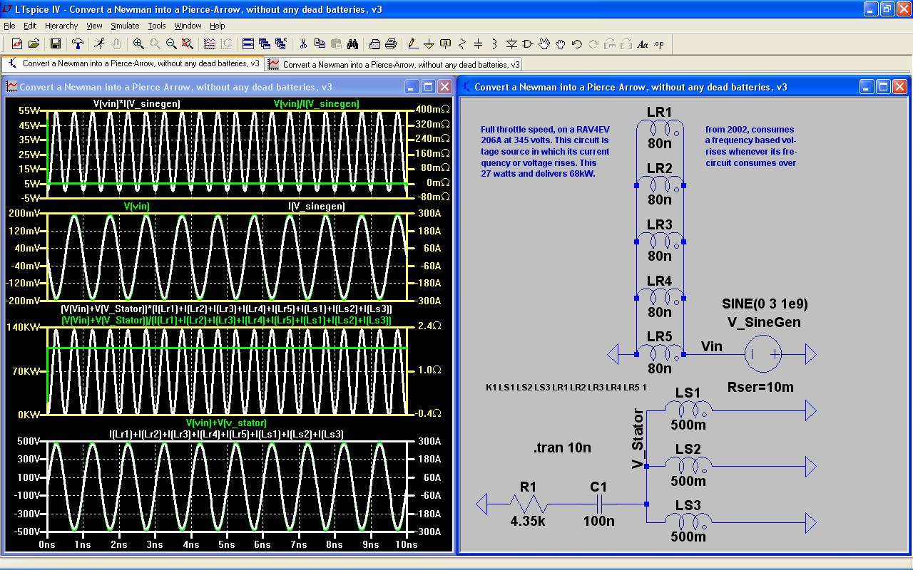Illustration 1: 140kW peak to peak.
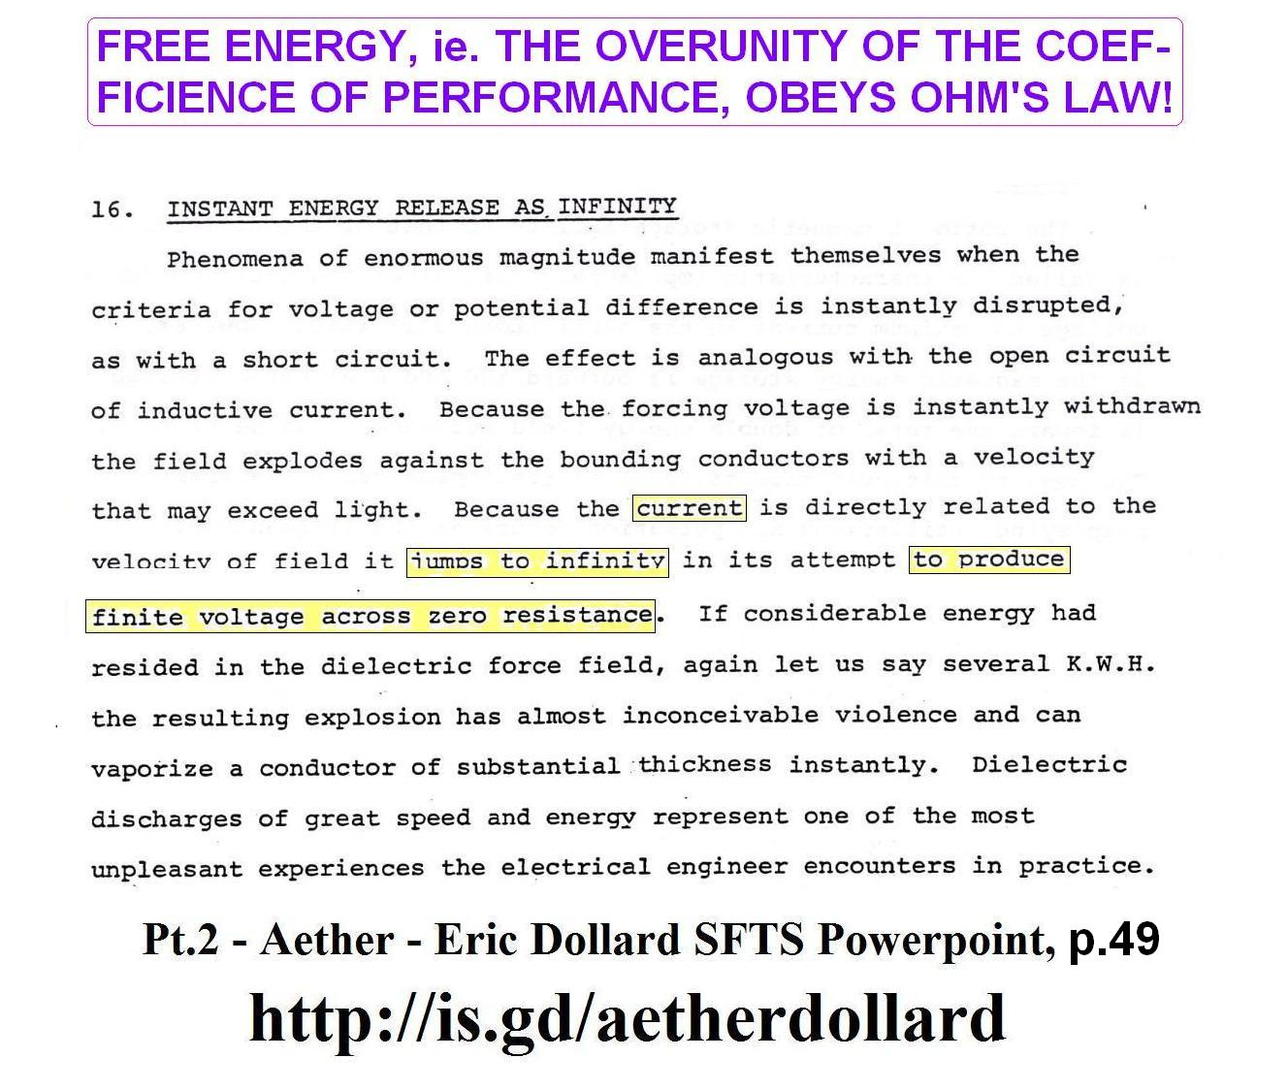
Eric is describing the hyperbolic function of division with regards to a finite sum of potential (voltage) divided by a nearly, infinitely tiny, resistance yields an infinitely large, current. For example...
When one volt is applied to a capacitor during its charging phase, then it is also resisted by a nearly infinite quantity of Ohms arising from its capacitive storage preventing its release. This nearly infinite resistance transforms itself into nearly zero resistance during the capacitor's discharging phase resulting in a contraction of its charge/discharge duty cycle, namely: how much duration does a low level capacitance spend to charge and discharge versus how much duration does it spend resting (doing nothing)?....

The relationships, above, are based on contrasting the status of a capacitor during its charging phase in contrast to its discharging phase. From the point of view of a capacitor of extremely low Farads, resistance varies drastically between these two phases causing an acceleration of discharge current if the capacitance is kept to a level low enough to disqualify it as a “shock absorber” and redefine it as a reflector/mirror so that time-delays between charge and discharge is minimized towards zero. It is this reduction of time-delay which parallels the acceleration of current upon release of its stored potential due to a contraction of its time domain. We're talking major Quantum Physics, here!
This is what happens in the simple circuit, up above, in which a high frequency of alternating voltage has its polarity inverted (switched) rapidly across a finite input of 3 volts of sine waves. The result is a huge current blasting out of this circuit requiring several thousand Ohms of resistance to thwart this tremendous surge into a reasonable quantity of amperes and also raises its voltage in proportion to its current so that a pair of A/C motors inside a RAV4 EV from 2002, can appreciate...namely, 345V and 206A (more or less).
Here is what would have happened had the resistance been zero at R1...

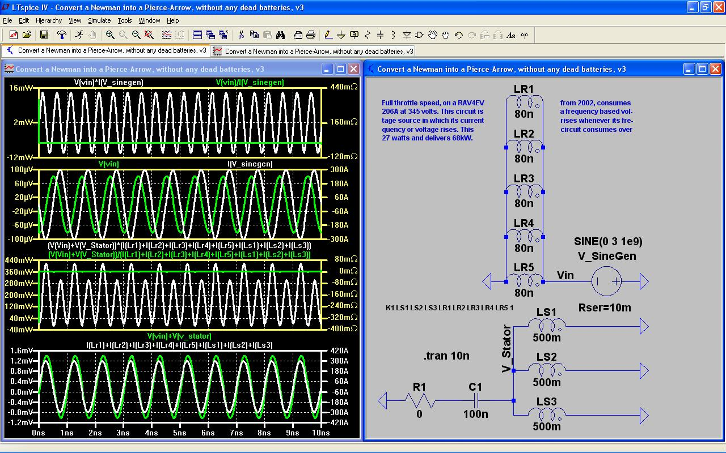Illustration 2: 440mW peak to peak.
See the difference? This circuit takes resistance, at R1, and translates it into voltage as a direct one-to-one relationship at LS1 and LS2 and LS3. Any increase of resistance at R1 results in an increase in voltage, not only at the stator coils, but also throughout the circuit. But this does not impact the current in any way whatsoever since the current is a byproduct, not of voltage drop, but of a combination of factors, such as: the inductive smallness and the numerous quantity of rotor coils, at LR#, plus the largess of this circuit's input frequency (one Giga Hz at V_SineGen). But if I keep the resistance of 4.35KΩ intact at R1, and double the voltage input at V_SineGen, then I get a quadrupling of wattage – probably due to both a doubling of current and a doubling of voltage occurring at the same time?...

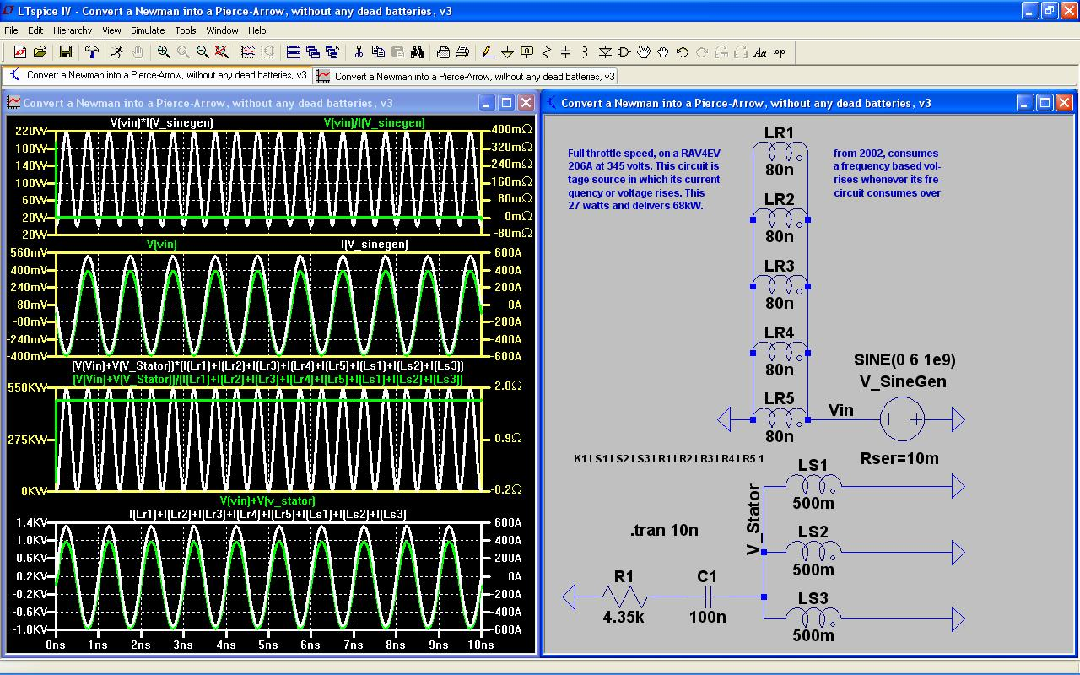Illustration 3: 550kW (peak to peak) ≈ 140kW (p2p) × 4.
The wattage increases by a factor equal to the squaring of the increased input voltage...

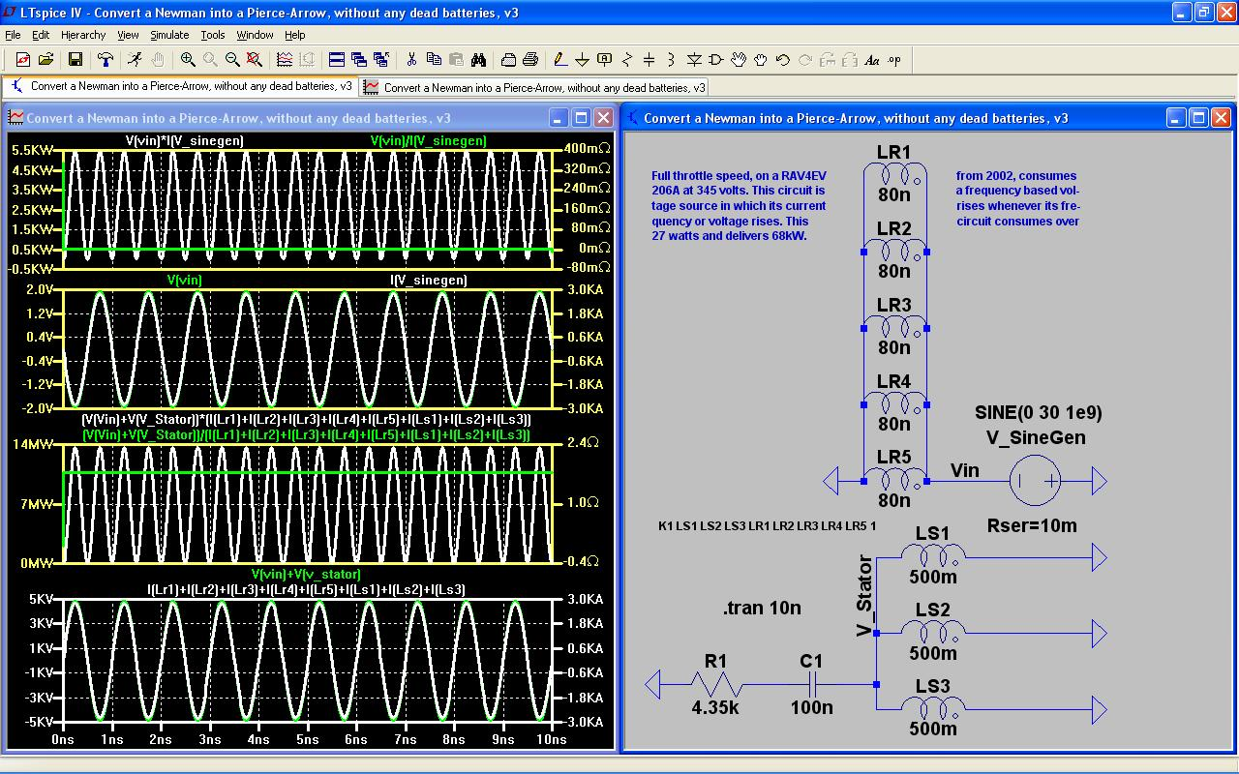Illustration 4: 14mega watts (p2p) = 100 × 140kW (p2p) due to Ohms Law in which current times voltage yields wattage. Thus, 5kV (p2p) = 10 × 500V (p2p) {times} 3kA (p2p) = 10 × 300A (p2p) {equals} 14mega watts (p2p) = 100 × 140kW (p2p). This results in a huge savings of drainage of the voltage source making it very desirable to use something other than a pack of batteries to power an EV.
History (according to Wikipedia) cites the invention of the lead-acid battery to have occurred around 1880. History also cites the development of an aluminum anode and lead cathode diode (using an electrolyte of baking soda or borax) to have been commonplace a century ago. This puts diode and lead-acid battery technological developments in roughly the same time frame.
My guess is that the Ammann brothers may have known about all of this and used it to their advantage referenced in both of their newspaper interviews (the Arizona Republican and the Denver Post articles) in which C. Earl Ammann claims the use of mineral/s, in addition to the use of iron wire, inside the barrel/drum housing his circuit. This could imply their use of the minerals of: lead, aluminum, and trona (the raw material from which baking soda is derived) and/or borax if they included diodes in their circuit. But as we will see, down below in a Micro-Cap simulation, that a dead battery can be incorporated into this circuit without impacting its performance if the battery's contribution of voltage does not exceed certain limits of influence.
I bring this up only because it is so advantageous to use diodes to insure the correct direction of current when charging batteries within the context of an alternating electrical environment whether or not they used them. And diodes (of a century ago) could be construed to be a derivation from lead acid batteries, or vice versa.
I take inspiration from attempting to solve other inventor's mysteries without necessarily trying to replicate their inventions, exactly, as they implemented them...
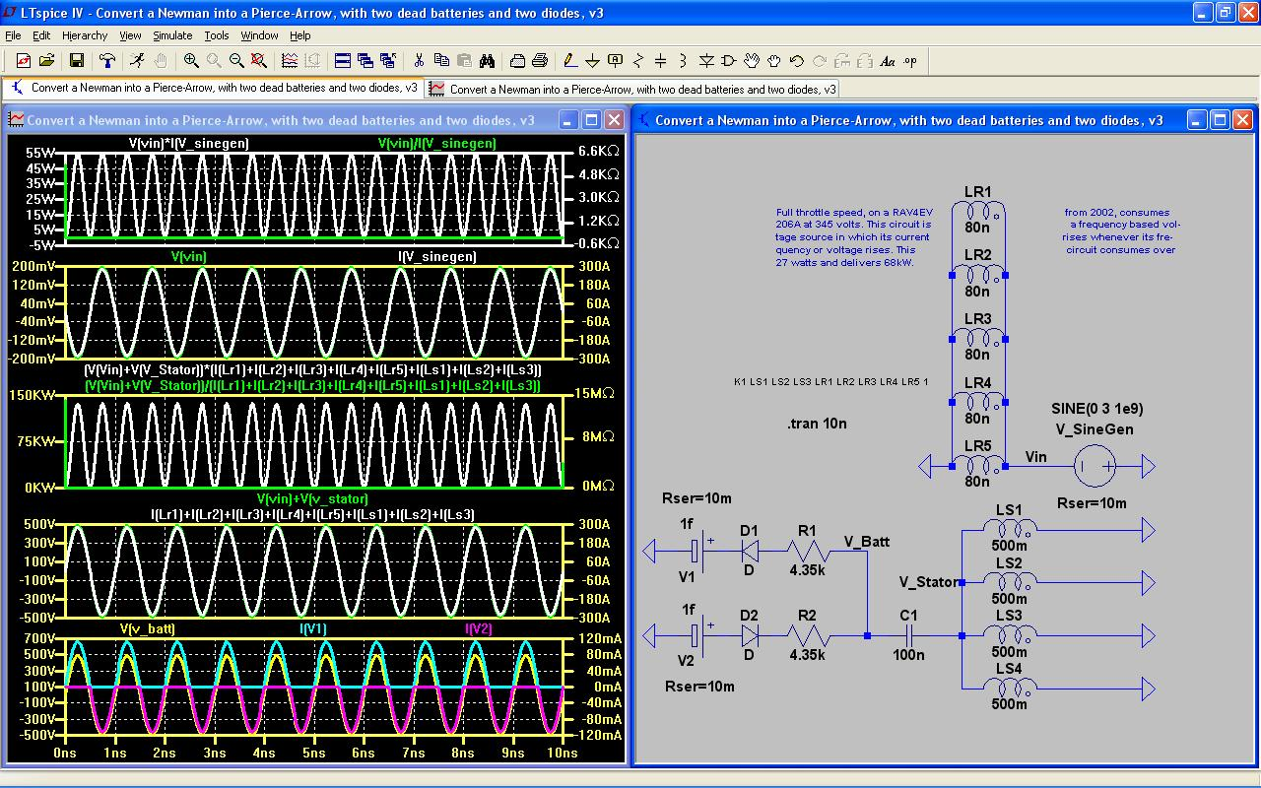Illustration 5: Notice how the orientation of dead battery #2, V2, is turned around backwards for recharging to take place? Yet, its oscilloscope tracing exhibits an in-phase condition between its current of I(V2), colored in magenta, and its voltage of V(v_batt), colored in yellow? Since all flavors of Berkeley SPICE simulators have their current out of phase with their voltage by one-half cycle of 180º of separation, this in-phase condition tells me that the right thing is occurring, namely: that the batteries are not acting as generators producing current, but are -instead- becoming recharged with current. Yet, to do this requires that battery #2, V2, be turned around cockeyed! Shows how little I know about electrodynamic theory if I can't explain this... ;-) While we're at it... Take a look at the input voltage of V(vin) versus the input current of I(V_sinegen). Their waveforms are in total alignment! This implies that this sine wave generator is no longer generating current. Instead, it's had its voltage polarity inverted by the more powerful influence of this circuit imposing its polarity upon the sine wave generator which will probably damage the generator if it is not a simple circuit fed by nothing other than an aerial or something similar. I frequently forget how limited is the protection provided by a single diode in that it merely prevents the alternation of current. It does not provide any protection with regard to the alternation of voltage. Hence, it may become necessary to use a full, bridge rectifier of four diodes rather than merely one diode on each battery? Perhaps... The following schematic (on the next page) will have the current of its sine wave generator artificially inverted to highlight what I am saying by multiplying it by a value of negative one...
The charging scheme, up above, amounts to a trickle charge intended to top off two very dead batteries, V1 and V2, while the car is in motion since there's plenty of wattage available to power the motor coils, then there isn't any need to recharge each battery with any current greater than this.
Since it only takes three volts to run this power supply, the gain in output amply supplies sufficient power to drive the car and top off two of its batteries at the same time – assuming only one additional battery (battery #3 “behind the scenes” and “out of sight” powering V_SineGen) will be running this vehicle's motor/s while batteries #1 and #2, V1 and V2, will undergo recharging.
Only three 12V batteries need be used to power this vehicle: one to power the motor while two get recharged on a rotation basis. Since the transformer of three 'stator' coils and five 'rotor' coils will probably consume space similar in volume to the missing nine batteries of a conventional EV, the weight of this setup and its volume is probably the same as a conventional EV?

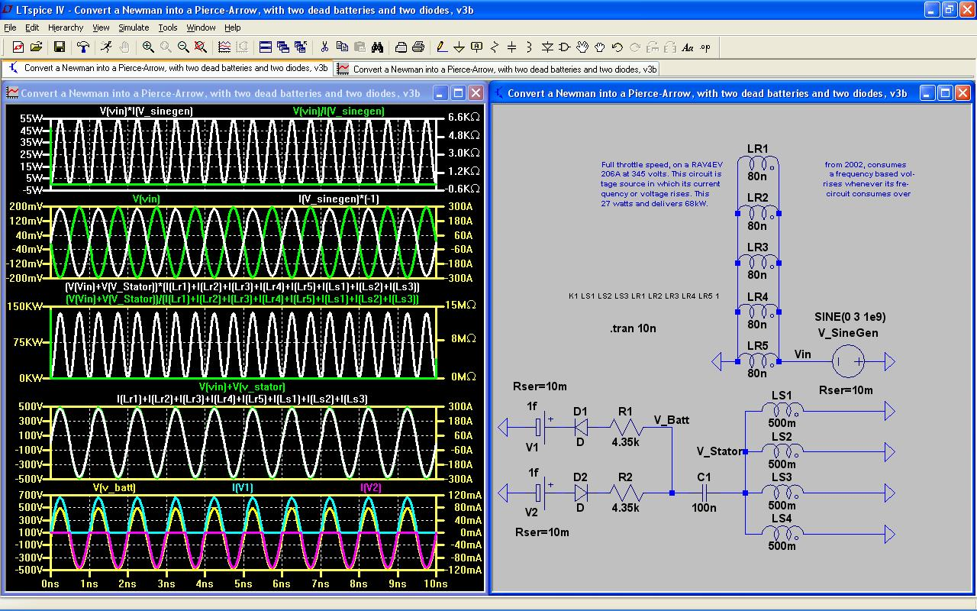Illustration 6: An artificial alteration of the current of the sine wave generator by multiplying it by negative one, I(V_sinegen) × (-1). If this condition had occurred all on its own with no help from me tweaking it with my mathematical trickery, then this would have indicated that the generator is doing its job and not in any danger of destroying its polarity. Hence, great care must be taken when deciding upon a voltage source for powering this generator lest that source be destroyed! I suspect that an aerial is the only solution, or else a solar panel? Since a solar panel putting out 12V may be too large to place upon the roof of a car, either this device must be a standalone appliance, or else an aerial plus a voltage multiplier involving diodes and capacitors may become necessary?

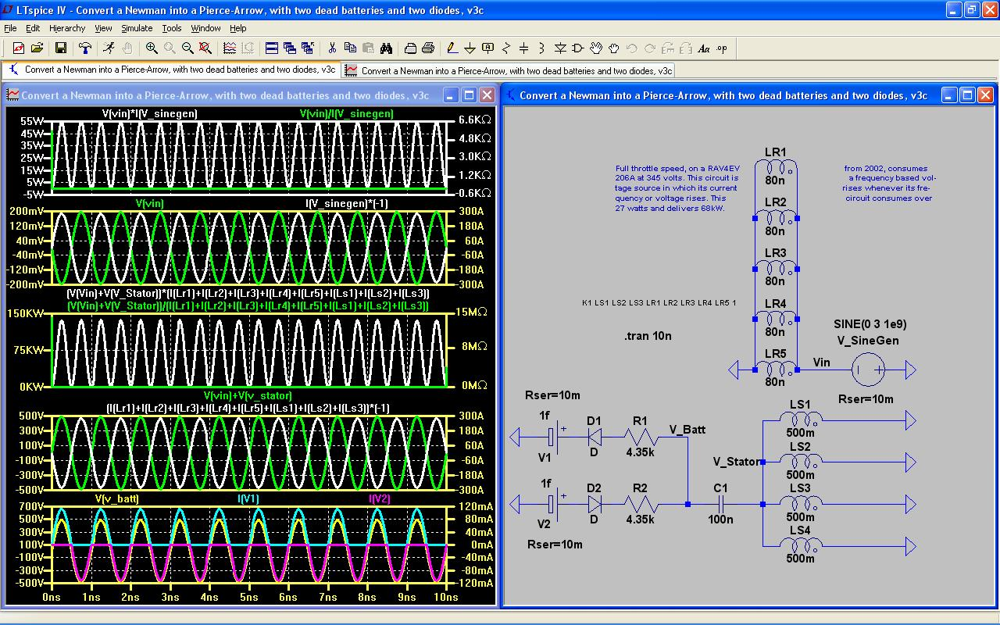Illustration 7: Notice how I have artificially induced, through mathematical sleight-of-hand, a similar condition to arise at the rotor and stator coils by multiplying their combined current by a factor of negative one? This has managed to shift their phase relation, relative to their voltage, by one-half cycle of alternation. This causes me to conclude that, indeed, it is this circuit's coils and capacitance (at C1) which is dominating the outcome resulting in the conversion of the voltage source into becoming a voltage load! This is in vast contradistinction to standard electrodynamic theory (which presently upholds the politicization of this science by the politics of physics) which always assumes that a voltage source, or a current source, will always and without fail (nor without question) always dominate a circuit's behavior! What a pile of you-know-what... This is probably due to the assumption that the magnetic coupling between the rotor coils and the stator coils will always fall short of unity, or nearly unity, sufficiently enough to deny this circuit from achieving this enviable condition of overunity.

In the illustration, above, notice how both batteries, V1 and V2, have become loads and may no longer be considered as sources of voltage since the phase of their charging current is in-phase with the phase of their charging voltage. This is what we want to occur, here. The unfortunate consequence, as noted previously (above) is that, since this is a byproduct resulting from this circuit becoming an overunity device capable of dominating its voltage sources, this also has the consequence of converting the voltage source, V_SineGen, into a voltage load which may do it damage if remedial steps of one type or another are not taken ahead of time to prevent this from happening.
We shouldn't have to suffer unacceptable consequences resulting from desirable causations.
These are the details, and the complications, associated with “free energy” (overunity) devices. They are not simple flashlight circuits obeying the corporate-oriented laws of politicized physics.
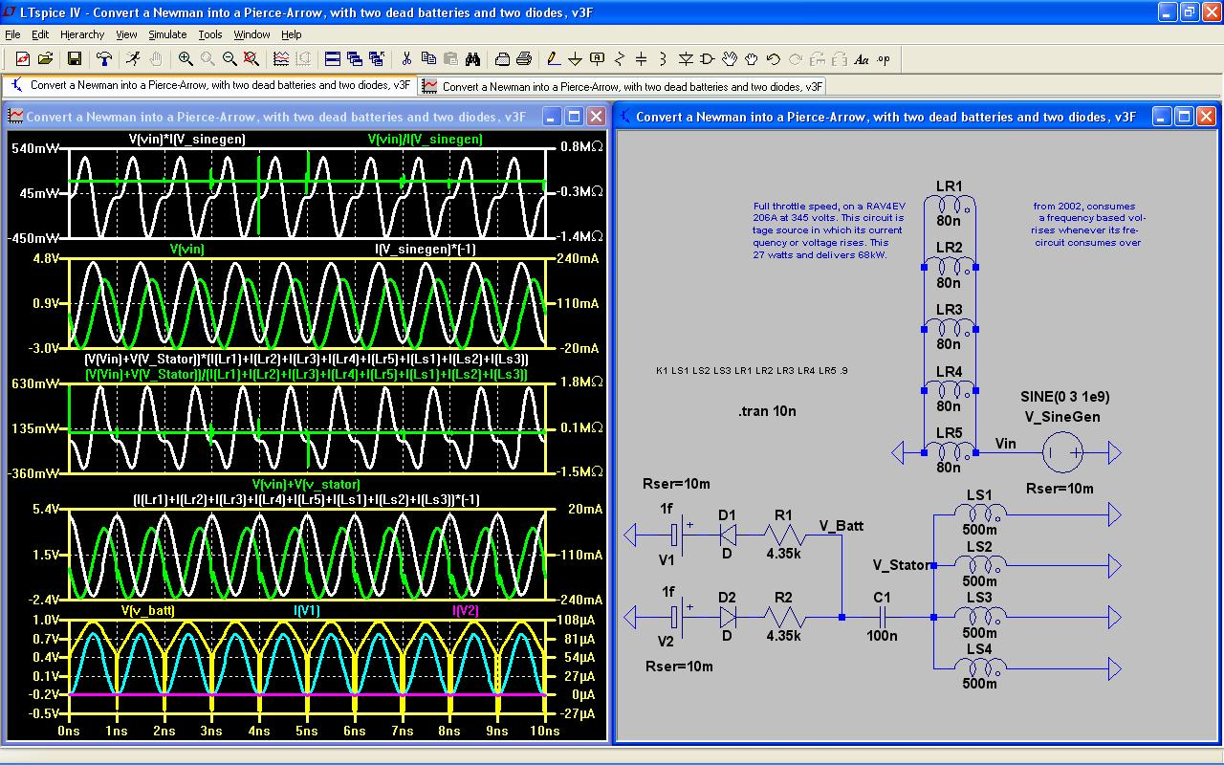Illustration 8: In this screenshot, the magnetic coupling between the five rotor coils and the three stator coils has been reduced to a mere 90%. This is where the wave-shapes at the batteries become severely deformed and the current of battery #2, I(V2) colored in magenta, has flattened out to a miniscule value probably requiring the reversal of its terminal connections within this circuit to what is considered normal for recharging purposes (and similar to the orientation of battery #1, voltage source: V1? The current phase angle of the sine wave generator, I(V_sinegen), has become lagged behind its voltage phase angle by a factor of 90°....precisely the same as what standard thermodynamic modeling (and its so-called laws – which I call its rules of thumb) predicts (and requires our obedience, thereto, if we want to maintain our respectable reputation in a society dominated by vested interests – none of whom have asked for your opinion, nor mine, before embarking upon this journey called: social engineering. Any coupling coefficience above that of 90%, used in this example, and less than the ideal minimum of: .9999999 = 99.99999%, will improve performance dependent upon how much greater than 90% does this coupling approach unity.

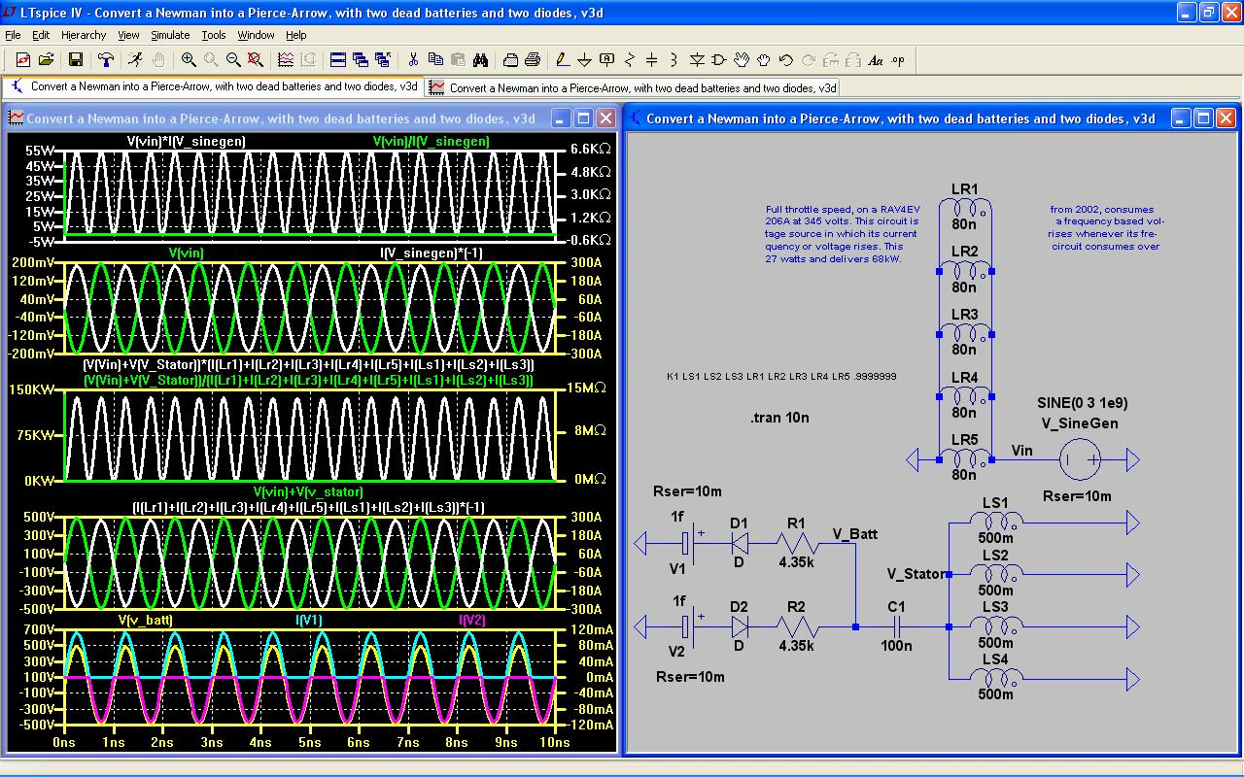Illustration 9: It takes a magnetic coupling coeffience of at least .9999999 = 99.99999% to equal the resulting effects from using a coupling of one (see, Illustration 7, above, for comparison). Nathan Stubblefield used a bimetallic winding of bare iron wire cowound among his insulated copper windings in his, “Electric Battery” patent # 600,457 of the 8th of March, 1898. And Oliver Heaviside recommended the use of bare iron wire, or ribbon, wrapped around an insulated copper core to fulfill his mathematical analysis of the trans-Atlantic telegraph cable problem of the late 1800s. So, why shouldn't we do likewise?

The only question left out of this monologue up until now, is: how does a Giga Hertz sine wave rotate a motor?
Easy! Pulse Width Modulation of square waves produced by the on-board electronics to mimic the characteristic 180 Hertz, or less, sine wave needed to rotate the motor shaft.
Since speed, for an A/C motor, is a consequence of Frequency Modulation, there won't be any difficulty varying the input, sine wave frequency to match the required output, square wave frequency.
These batteries are paired in parallel for recharging them and then they are discharged one at a time giving credit to Nikola Tesla for this pairing concept derived from his 1889 patent: Method of obtaining direct from alternating currents – US 413353 A; Published on the 22nd of October, 1889 and filed on the 12th of June, 1889. This is (ostensibly) Tesla's method of adding A/C to D/C. I merely replace Tesla's resistive loads (of his use of lamps) with relatively large resistors to adjust the proportionality between the voltage and current to get it to be within the window of a 2002, RAV4 EV.

There is a consequence to using a motor as a transformer/generator...
...which results in the undesirable loss of output since its rotation will complicate matters by adding a wave of considerably lower frequency which, for some reason beyond my expertise of comprehension, causes a reduction of output below what is desirable to maintain. Again, pulsed width modulation may be the solution. But it may also become necessary to increase the input voltage and/or increase the input frequency at V_SineGen?...

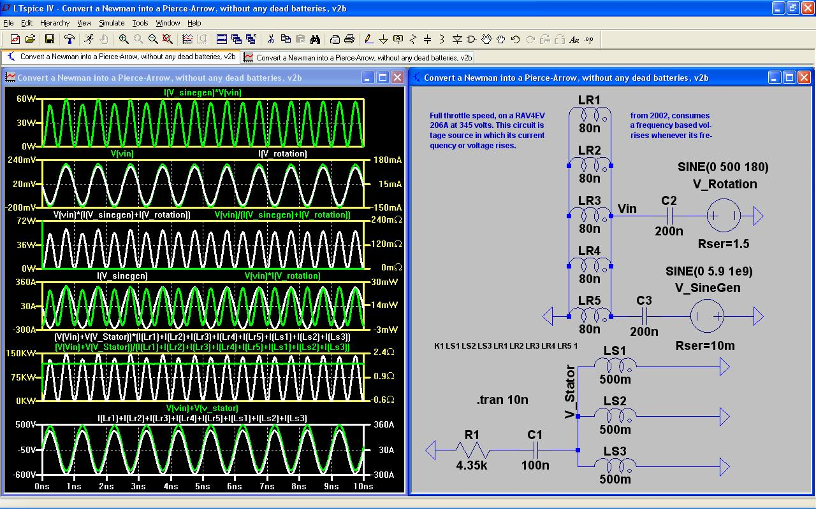Illustration 10: This example raises the input voltage and leaves the input frequency alone. You will notice there are no batteries undergoing recharging. That is due to my not having included them at this stage of development of this device. But don't fret... Their inclusion, or exclusion, amounts to no alteration whatsoever since the batteries which I have been using, up until now, are not fresh batteries of considerable voltage. Instead, they have been dead batteries....very, dead batteries up until now of 1 femto volt which is the same as saying 1e-15V.

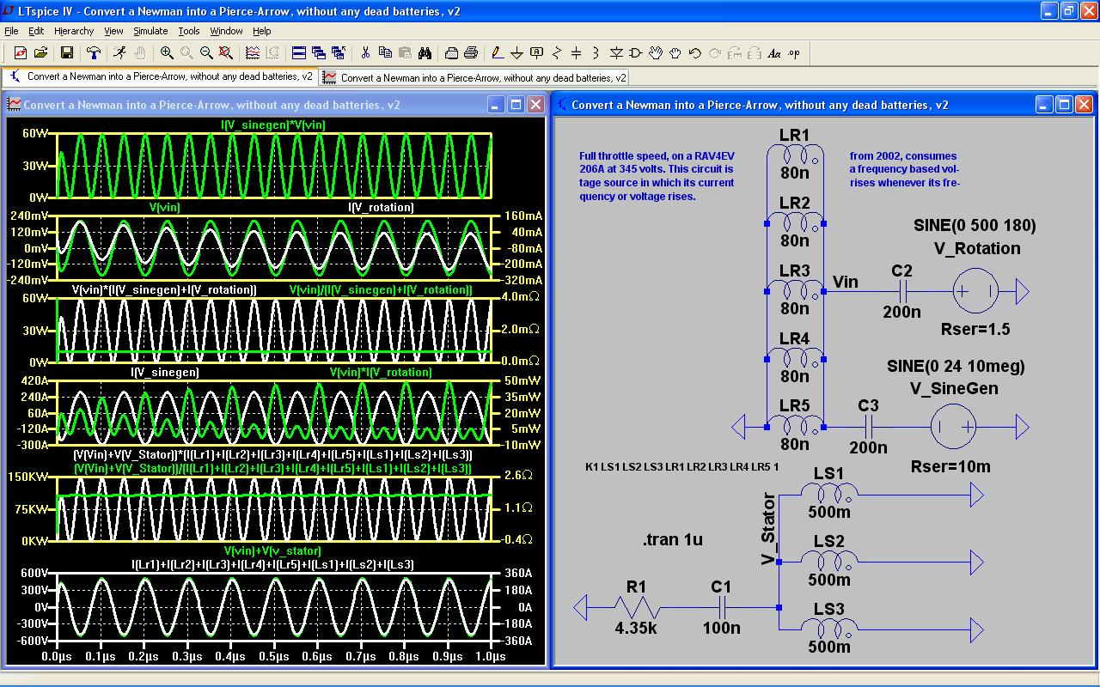Illustration 11: Here, in this illustration, the input voltage has been increased beyond 5.9V to a considerable 24V along with a reduction of input frequency towards 10 Mega Hz. In both of these simulations, I am assuming a 500V, peak to peak, contribution of 180Hz is coming from the rotation of the rotor since that is what I see under normal circumstances of running this simulation without any input arising from its rotation. So, I merely have to include that and see what happens... What happens, is that not much voltage nor current is added to the output. Yet, a considerable loss occurs, instead, which must be accommodated somehow or another.
Go back to page 8 and review Illustration # 7 and compare the impedance of all of its coils (depicted in the center window of virtual oscilloscope tracings).
The range of impedance in that illustration (on page 8) is from a low of 0Ω to a high of 15 Mega Ω. Yet, in the screenshot, below, its range is from –360Ω to +540Ω of impedance caused by spikes of impedance which affects the RMS calculation...

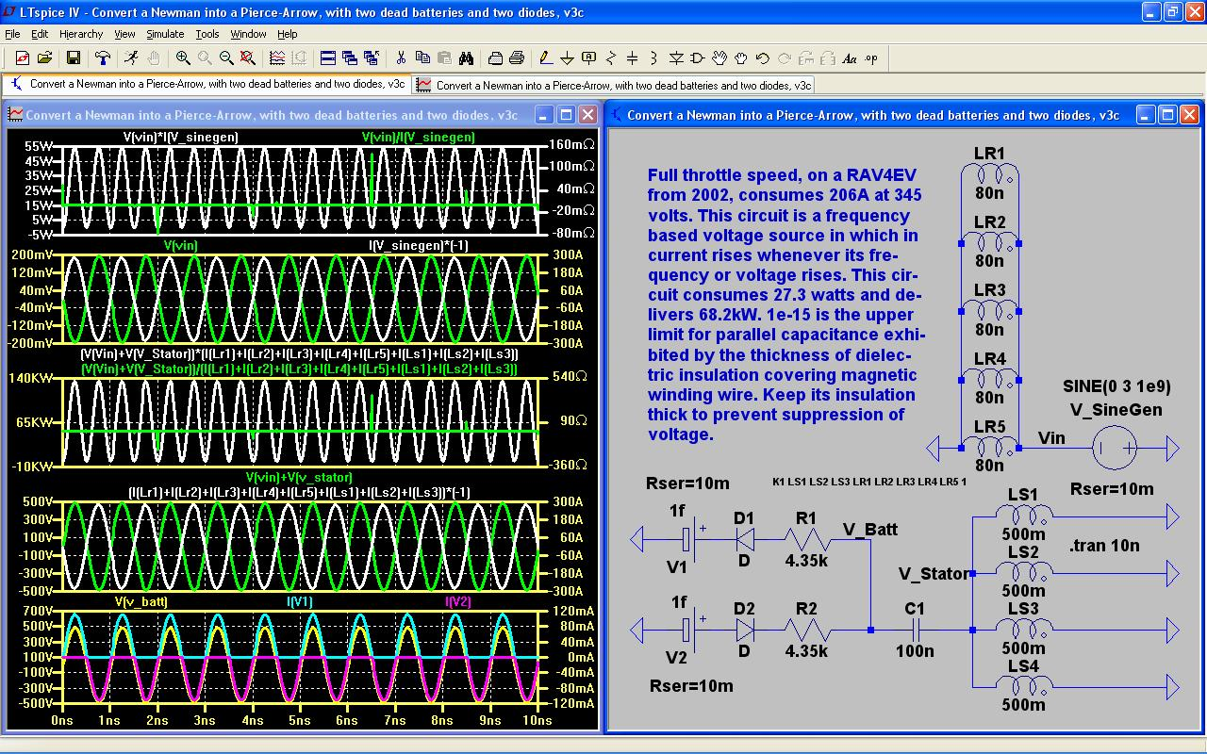
I added 1 femto Farad (1e-15F) of parallel capacitance to each and every coil (all nine of them). This did not detract very much from the expression of voltage. Nor did this small parameter increase amperage. Yet, it did have a beneficial effect in reducing the magnitude of impedance spikes and shifted them away from occurring in the very beginning. This momentary tendency for a spike of impedance to occur in the very beginning (whenever a circuit is initially turned ON) is commonplace. Yet, it is not necessary. It may be avoided by this method of enlarging the thickness of the dielectric insulation surrounding all of the copper wire, including the magnetic winding wire, in order to delay impedance surges to occur at random moments throughout the duration of a circuit's operation rather than occur all at once, in the very beginning, and avoid its magnified intensity.
The second benefit to enlarging wire insulation is to insure that voltage not become suppressed. This seems to be a common complaint among “free energy” enthusiasts in their pursuit of their elusive goal.
The third benefit is the ability to “tune” an overunity circuit. If this parallel capacitance is not avoided (resulting from the thinning down of wire insulation ostensibly, enough, to economize coil volume), then it becomes very difficult to use standard techniques of varying the parameters of electrical reactance, such as: capacitance, inductance and frequency, in order to achieve whatever output is desired. This difficulty is due, not only from suppression of voltage, but also from acceleration of amperage. This makes it very difficult to avoid electrical explosions and motors and generators reacting very quickly with self-destruction.
The next image has had its parallel capacitances of all of its coils increased to 1pF (1e-12 Farads; one pico Farad)...

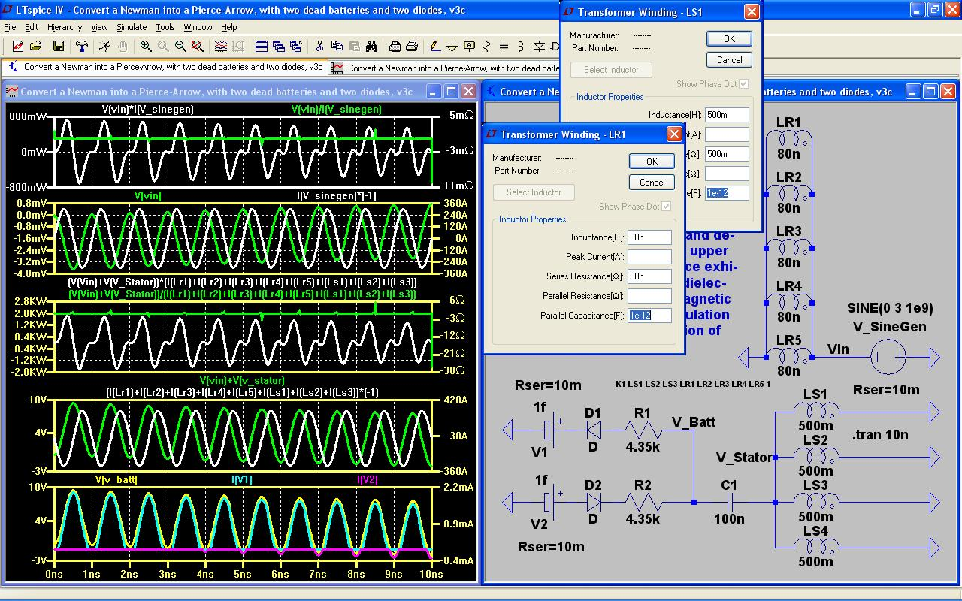
See what a difference a little extra padding of insulation can make? Enough to make the head spin...
These details are merely a few examples of pitfalls awaiting the engineer who endeavors to exceed common sense. These failures could easily destroy what little confidence we have already – considering how much lethargy and resistance to new ideas is pandemic throughout our collective consciousness.
In the next image, I've attempted to duplicate this problem in Micro-Cap (of using wire whose insulation is not thick enough to insure success) with similar results...
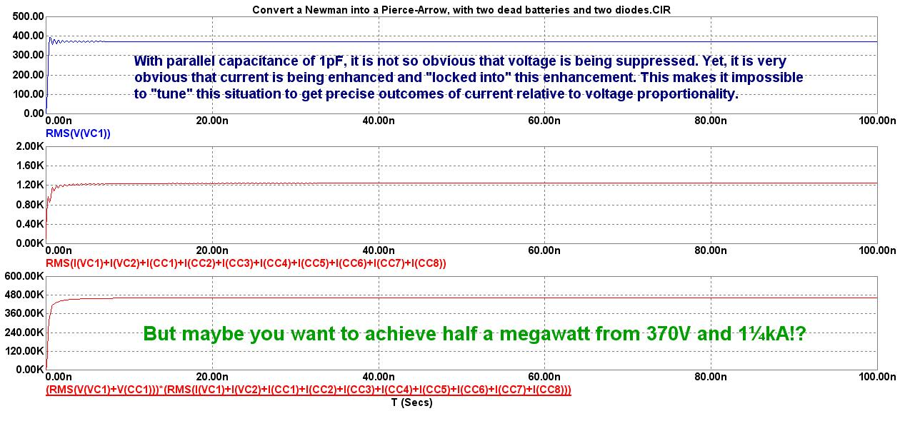
Here are the nodal voltages when the parallel capacitance is 1pF...

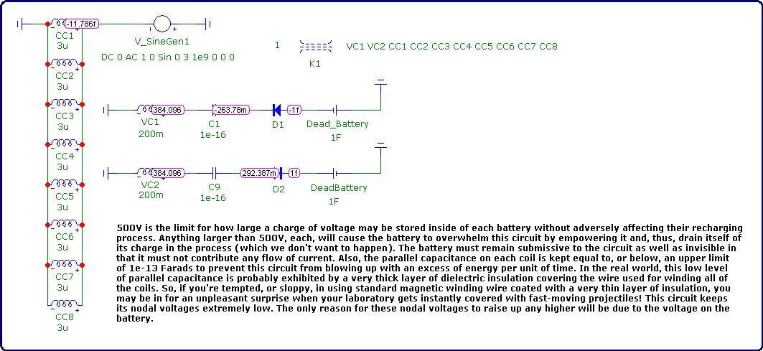
Here are the nodal voltages when parallel capacitance is not included...

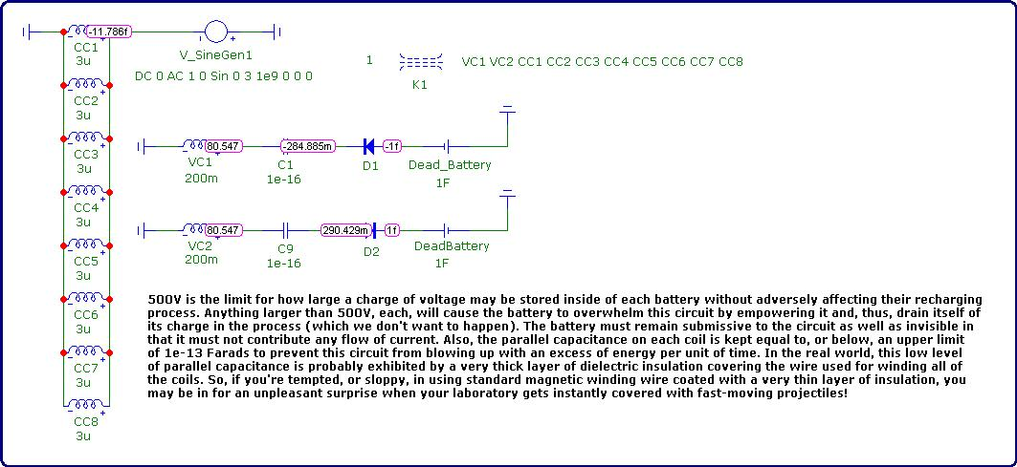

And here is the schematic without displaying the nodal voltages...

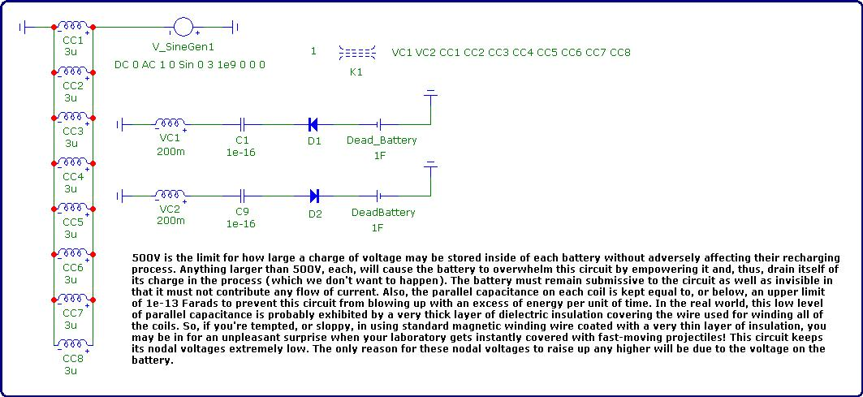
I made the following adjustment to the stator coils by eliminating their multiple parallel instances in favor of merely one stator coil since only one is needed to amplify/exhibit voltage. Yet, I retained the numerous rotor coils. In fact, adding more rotor coils may make it possible to reduce the high input frequency (along with other adjustments required in response to this one adjustment) since each rotor coil adds current to this circuit's performance. This may be why Tesla Motors uses a multifilar winding on their rotor coil?
The next adjustment I made was to refer to the motor performance characteristics of a RAV4 EV from the 1st generation era spanning the years between 1998 when they first came out and 2003 when Toyota terminated them. These parameters are available, online, from... http://evnut.com/
Then, I applied impedance and reactance formulae to compute a guess-estimate of how much inductance was being used by the RAV4EV's twin A/C motors so as to make my simulation more accurate...

Since the contribution of the reactive component is so small, I get to ignore it and merely focus on the resistance. And since I don't know how to deal with imaginary parameters, I'll ignore that as well.

It turns out that electric motors are largely inefficient due to their back EMF resulting from Lenz Law. As much as 80% of their voltage is wasted by its inversion of polarity.
So, if I take the fully charged, pack voltage of the RAV4EV's twenty-four 12V NiMH batteries of 288V and multiply by the reciprocal of 80%, namely: the factor of 1.25, then I get 360V as a maximum voltage (just as 288V is the maximum charge state for the RAV4EV's battery pack).
As I recall, the person who developed the motor controller for the General Motors EV1, Alan Cocconi, used an average of between 330V and 360V for his development of the hybrids' recharging system while cruising at 50-60mph on the highway delivering 50A to top off the battery pack of the 2001 RAV4EV and still have enough left over to power its motor while it cruised along. It could then use its full battery pack whenever it needed to accelerate. These are the stats which I use whenever I try to simulate energy saving solutions to the range limitations of battery-based EV's...
http://www.tzev.com/2001_rxt-g_library.html
So, I use an average of 345V, as my target/goal, along with the RAV4EV's full-throttle current of 206A to simulate the worst-case scenario of accelerating up a hill for prolonged periods of time.
Assuming a rotation speed of approximately 11k RPM for the RAV4 EV moving along at 100mph, I plug 180Hz into the following formula after swapping variables around a bit...

§1

All of this was based on my initial assumption of the stator coils being a combined total of 1.7H, or thereabouts.
So, the circuit's resistance, at R1 and R2 of 4.35kΩ, was due to this assumption.
But now, I get to me more accurate.
By reducing the number of stator coils to merely one coil (since only one is needed to accumulate a high-voltage and low-current characteristic within itself), and by running the simulation with this new parameter of the stator coil's inductance, I get a revised voltage different from my target of 345V. Then, I adjust the resistance at R1 and R2 to accommodate this alteration of output by multiplying a ratio against each resistor proportional to the multiplicative difference between my target and this newly revised output of voltage. Then, I plug the revised resistance into the formula, above at §1, and recompute the newly revised inductance all over again, and repeat these steps until I'm confident that I've converged upon a definitive answer of somewhat accuracy.
This is called a self-looping, iteration of approximations; a well-known mathematical process...
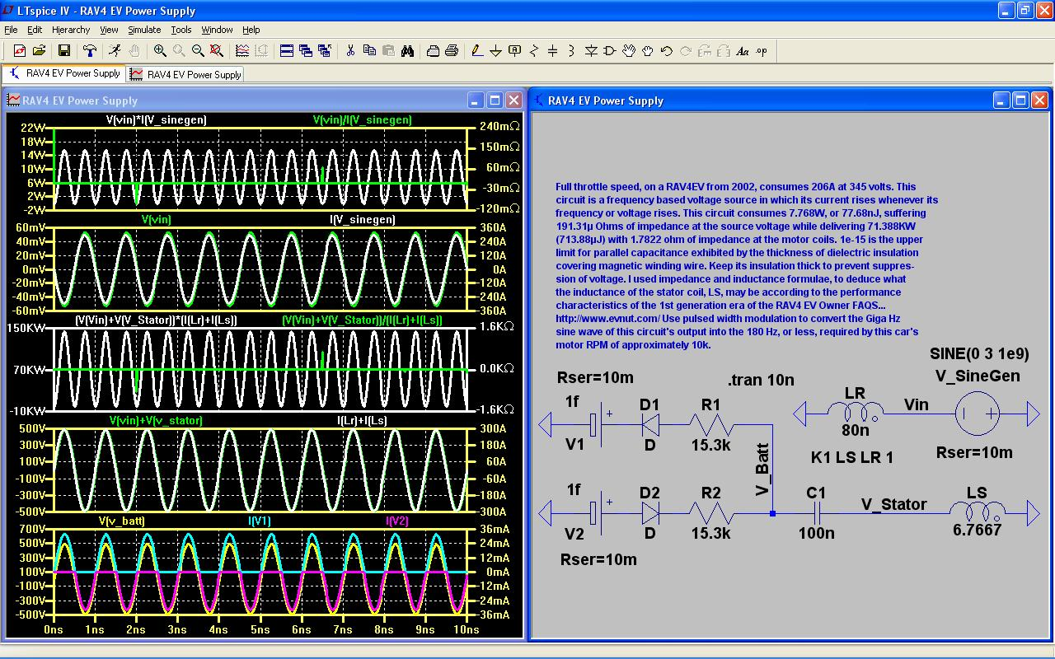Illustration 12: A combined resistance of 7.65Ω at R1 and R2 with an inductance at LS of 6.667H. Parallel resistances are summed by taking their reciprocals and then reciprocating their summation.

