Preferred Embodiment, update...

The first order of business is to correct an error on the previous schematic which had stated that the total real power per pair of rotor and stator coils is 11½ Giga watts. That's the square root of what it should have said, which puts the correct figure in the vicinity of 132¼ × 10¹⁸ watts!
But if I place a very large resistor across – in parallel – to one stator coil, then I am provided with two options...
- If this resistor is 1 Giga Ohm, or less, then this becomes a shorted Stator Coil which shuts OFF this circuit's overunity and effectively turns around its time-domain to conform with conventional wisdom, ie. The Conservation of Energy, in which time tends towards entropy, creating a self-damping waveform. Everyone in the electrical engineering industry is familiar with these signatures of normalcy.
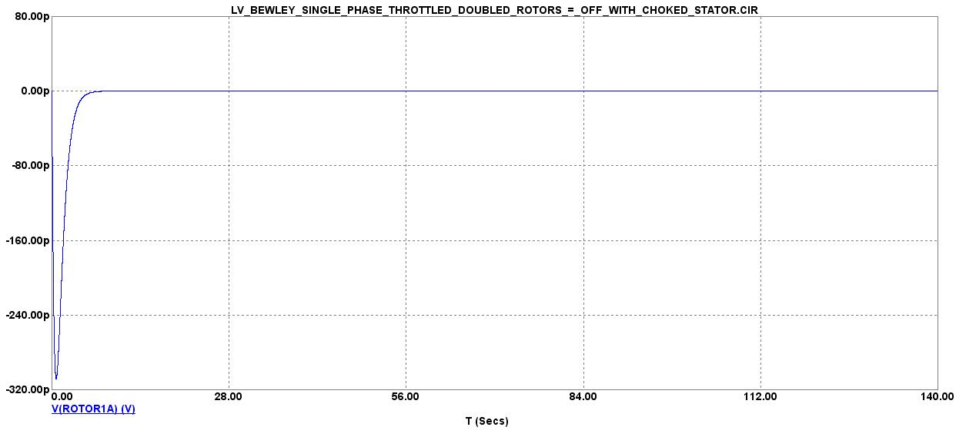
- But if this resistor is switched out of the circuit, then this circuit continues to achieve overunity, seemingly defying the Conservation of Energy, by reversing the conventional time-domain of “physics” which tends towards entropy. So, instead of surges being defined as transients to signify their transitory nature, and instead of these surges damping at an exponential rate which graphs a hyperbolic function as it approaches its asymptotic limit of zero, it would appear that their time-domain has been reversed creating what I like to call, “staccato wedgies”, which exponentially surge upwards towards infinity as their asymptotic limit. These are not normal waveforms. Yet, they are very real and occur whenever a over-voltage, safety switch is opened at a substation of the utility grid.

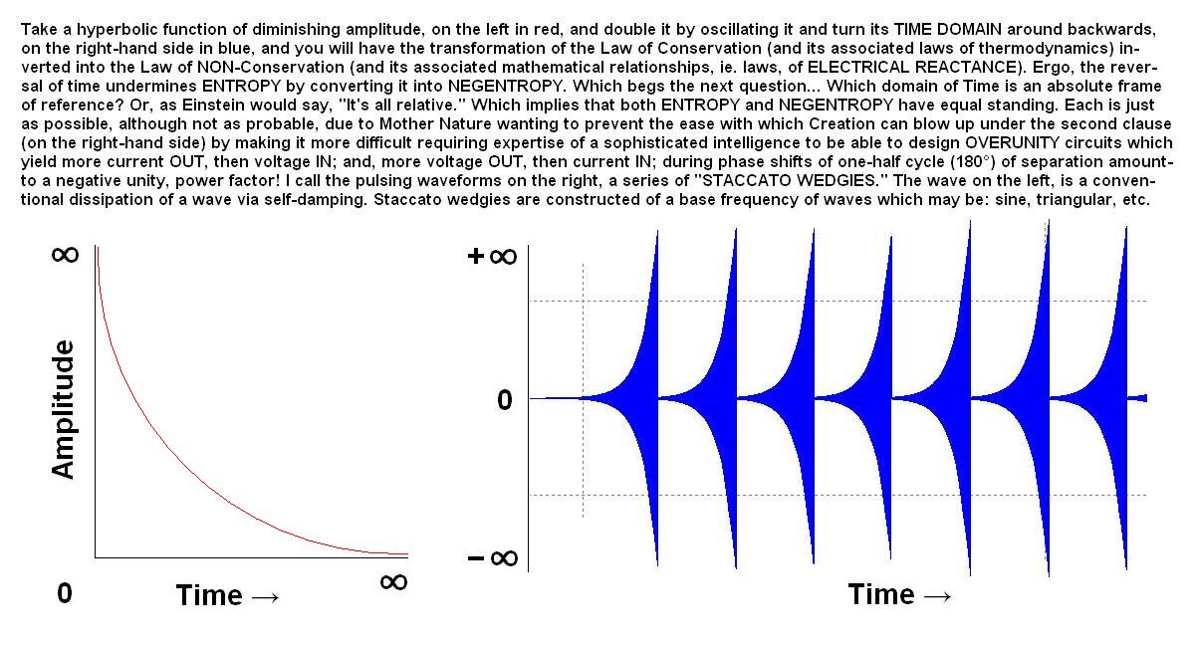
The other improvement I made to this circuit's scheme is the addition of a capacitor in parallel to each rotor coil which is set to a default of 5µF whose purpose is to regulate the frequency of the output and, thus, regulate the rotation rate of the rotor coil it is adjacent to. This, then, becomes a variable frequency drive, or VFD.
I still don't like the duration of pulsations spaced several seconds apart. That's too slow. The effect on passengers within an electric car (powered by this device) would be a lot of jerking, forwards and backwards, as it lunges with alternating acceleration and deceleration at too forceful a pace to avoid whiplashing everyone's necks and backs.
And, of course, the reactive power on each pair of rotors and their associated stator remains too high for EV use...

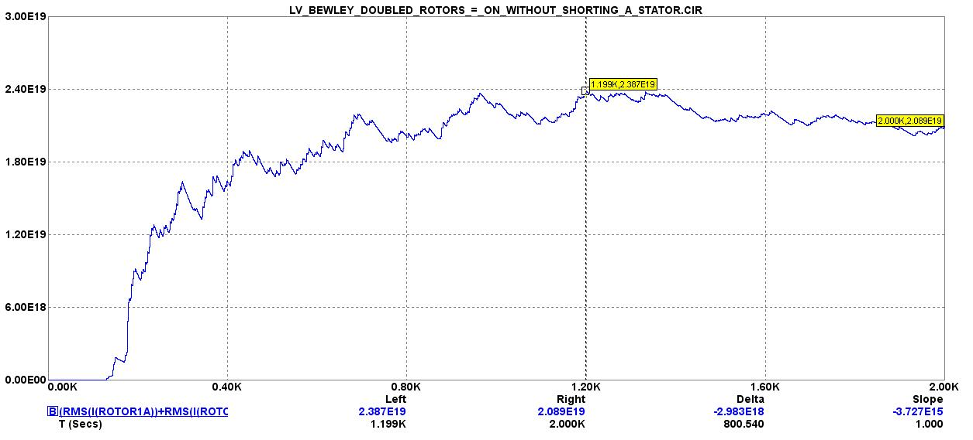
But the frequency of triangular waves is still around 130Hz...

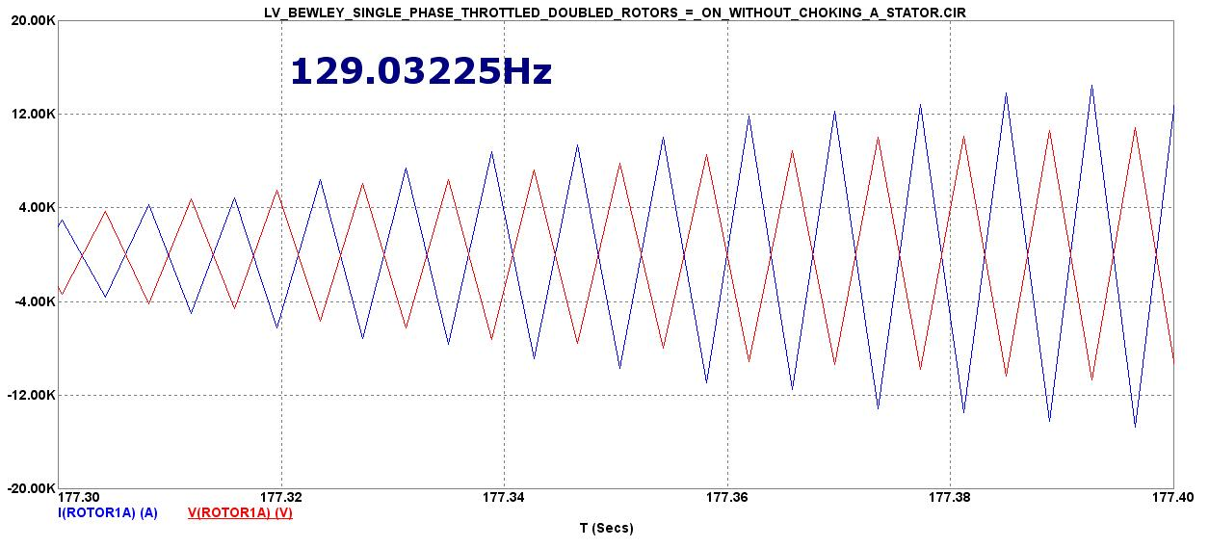
And resistors still manage to correct for power factor...

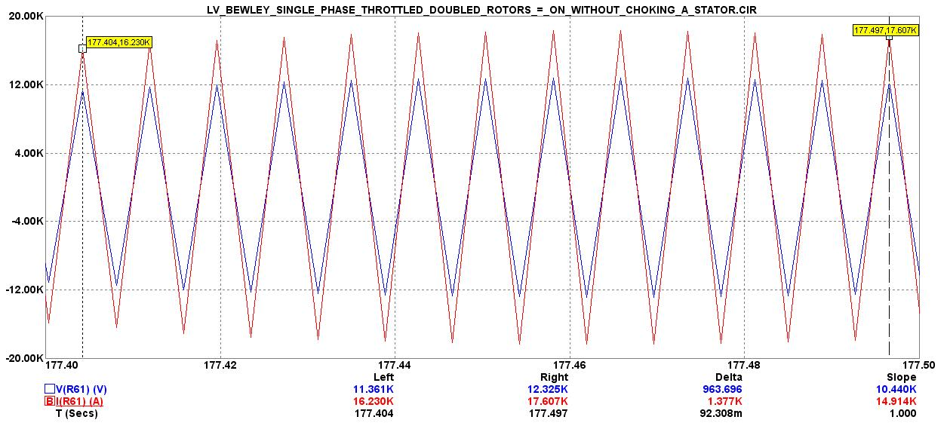

The total reactive power on each pair of rotors is...

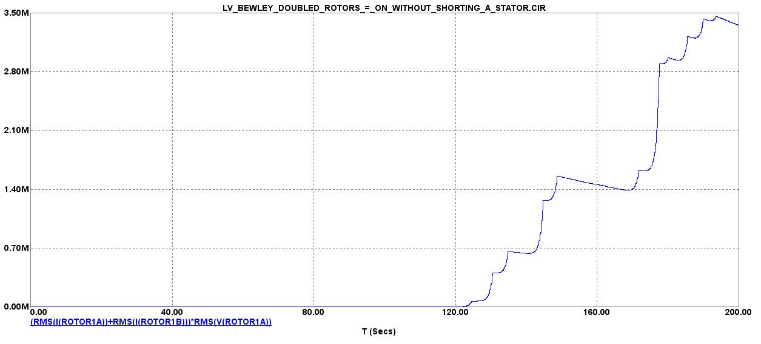
The raw amperage and voltage on one pair of rotor coils is...

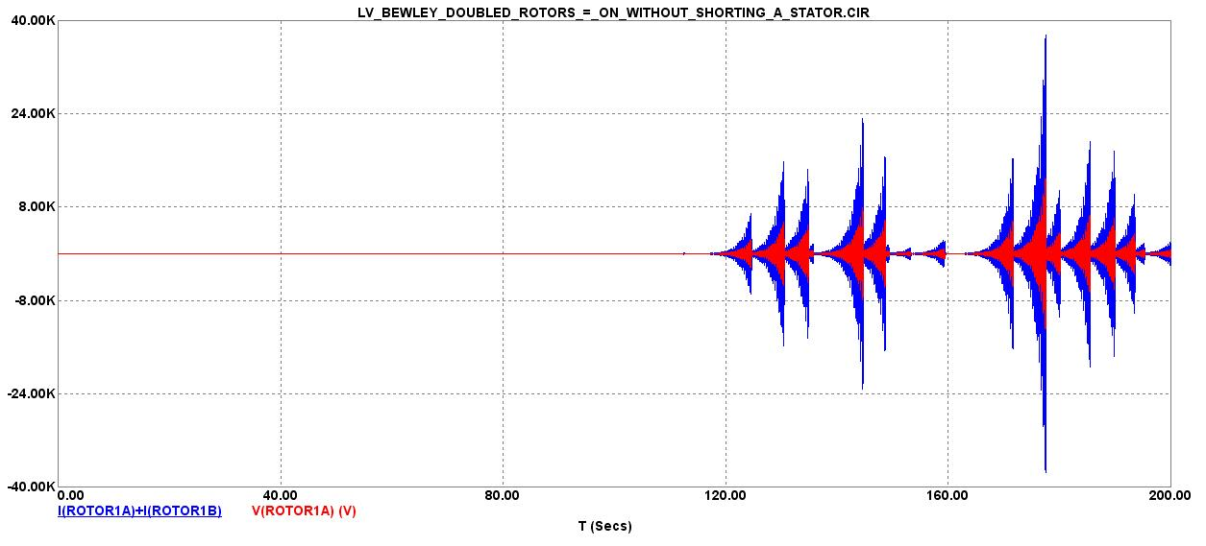
Giga volts is on each Stator coil...

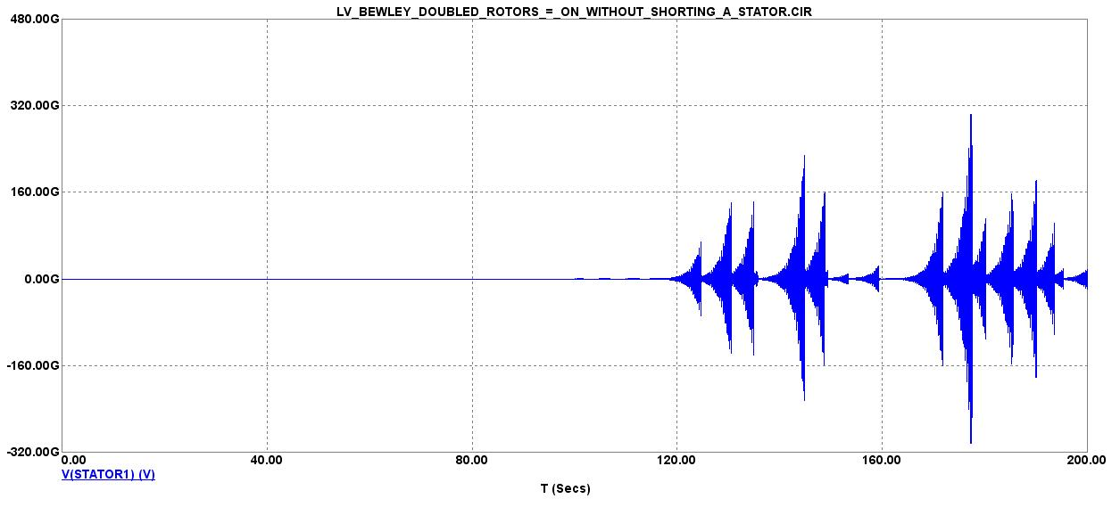
Here is the revised schematic with a dead battery across each helium bulb to enhance its output...
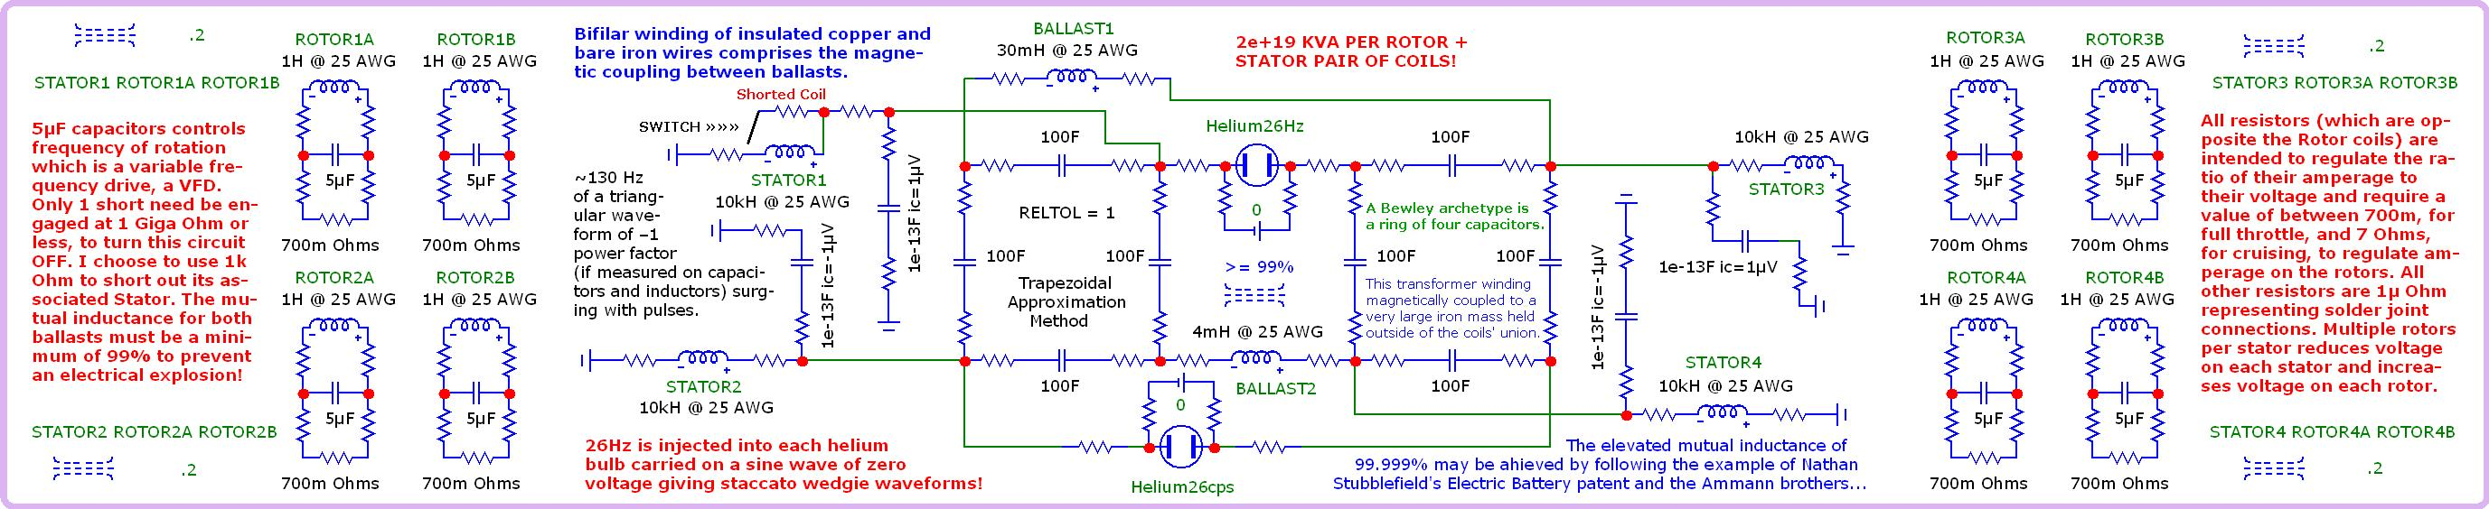
And here is its nodal voltages...
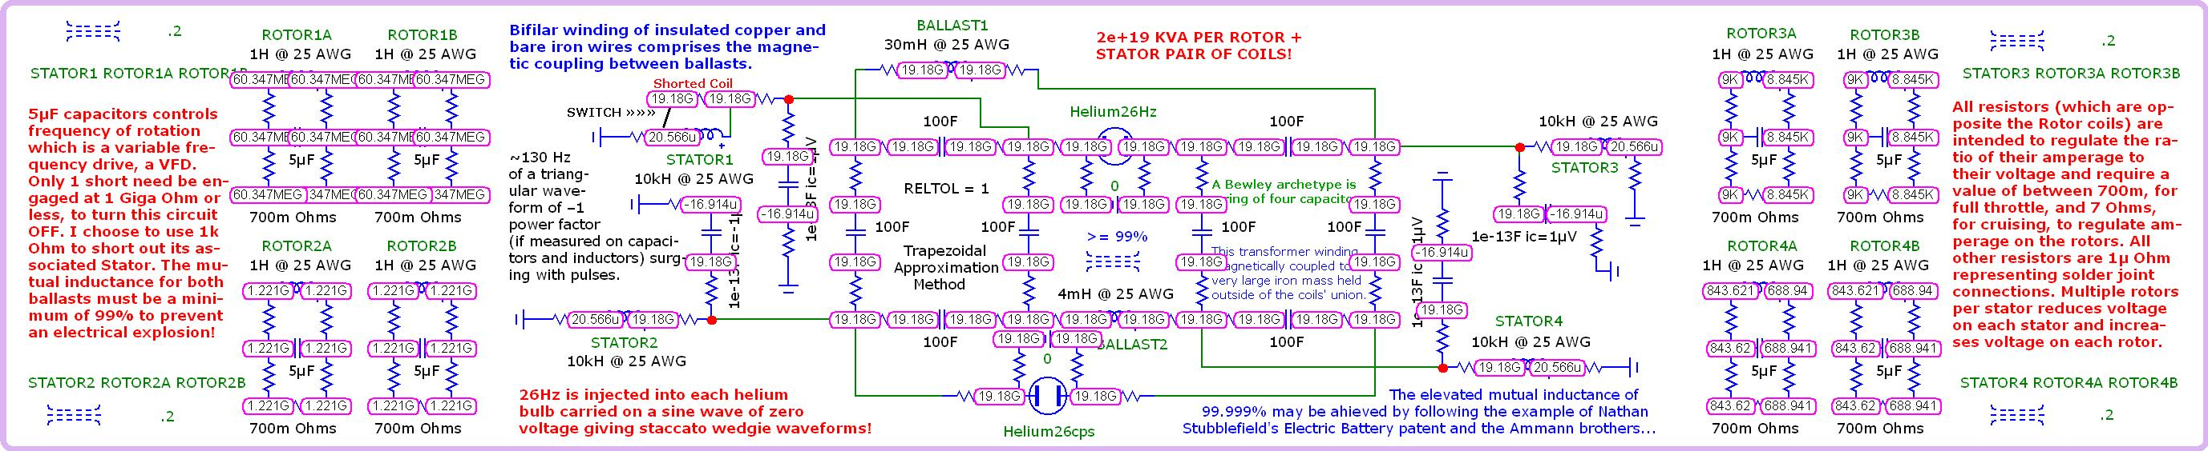
Here is the same circuit shut OFF by shorting out one of its Stator coils...
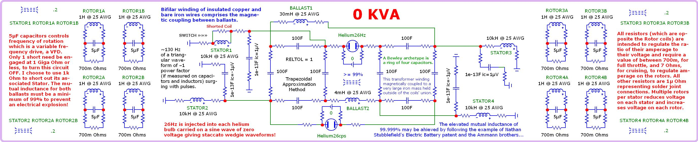
And here is its nodal voltages...


