Talk About Utter Simplicity!

William Lyne alleges a quotation from the lips of Nikola Tesla, in Lyne's book entitled: “Pentagon Aliens”, in the sub-chapter of his 18th chapter entitled: “Tesla's Special Generator” – “For every 200 pounds of iron added (magnetically coupled) to his device, one horsepower is increased at its output”.
That's a heck of a statement! Well, it looks even better when it's simulated in LTSPICE...

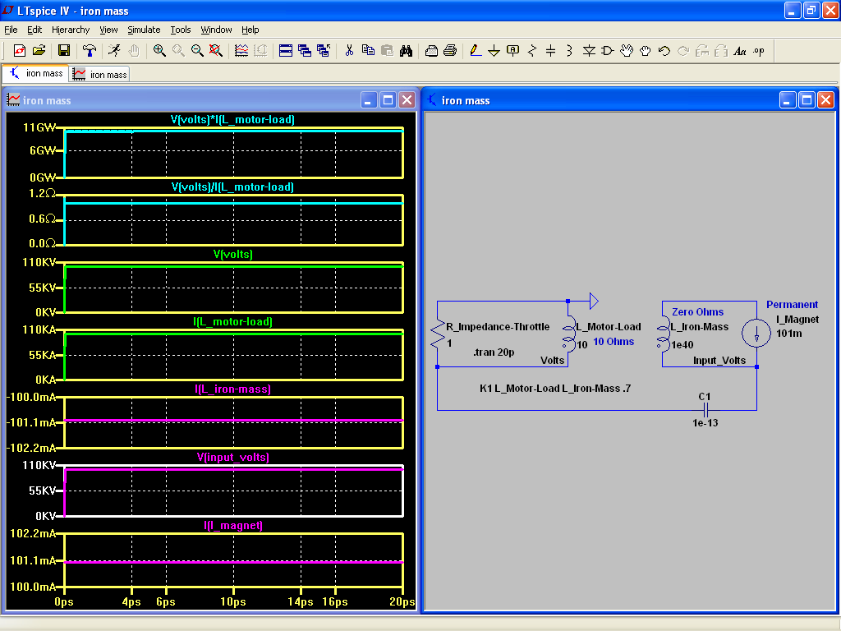

Hint...The reason why I tend not to add solder joint resistances is because it usually doesn't matter much whether I add it or not. Although it does tend to stabilize the output, it does not increase nor decrease by any significant degree. Sometimes, it increases the output at specific resistances as if a resonance point has been located. But, that's semi-rare.
This does not surprise me (any more). So, I hold these five parameters to be sacred whenever stylizing a circuit of overunity output...
- Frequency,
- Phase shift,
- Inductance,
- Capacitance, and...
- Resistance.

If we add frequency to it, it gets even better...

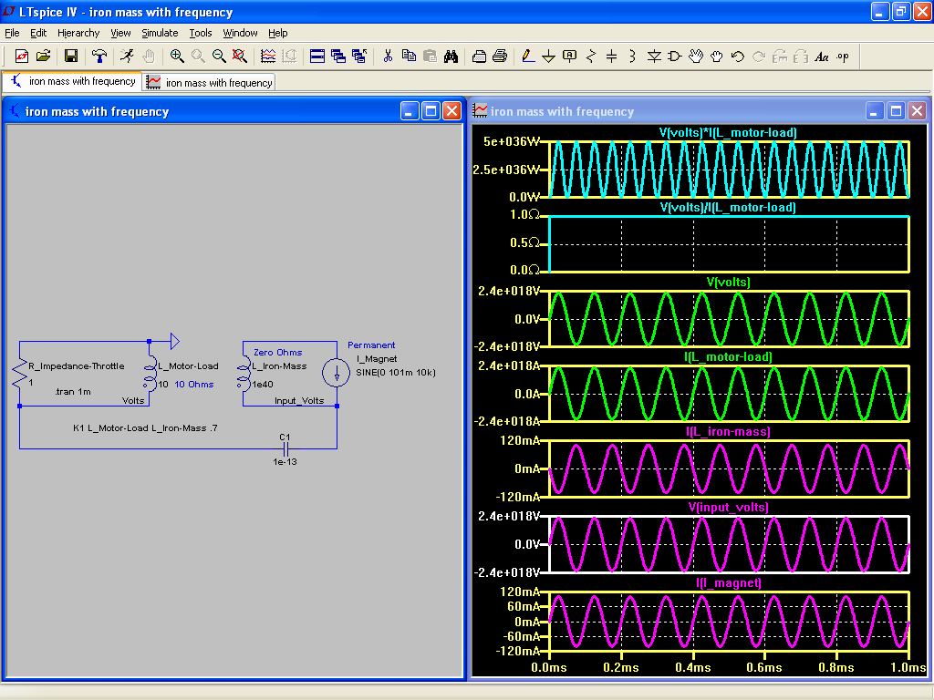

At this point, it doesn't matter any more whether or not we vary the frequency, for the output remains the same just so long as we utilize a frequency of one pitch or another – any wavelength will do just fine!...

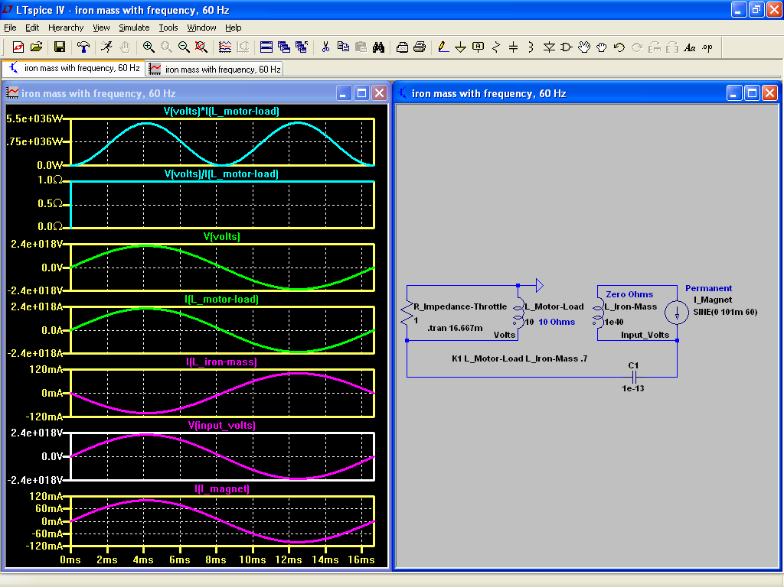
Wow! That's impressive!
Granted, it's just a simulation. But still...what a performance!
The inductance of L_Iron_Mass is given zero Ohms of resistance since it is assumed that magnetic flux does not suffer from impedance of any sort. But that's because I don't know how to include such things as magnetic “permeability” or the like.

The following screenshots are Micro-Cap equivalent simulations...
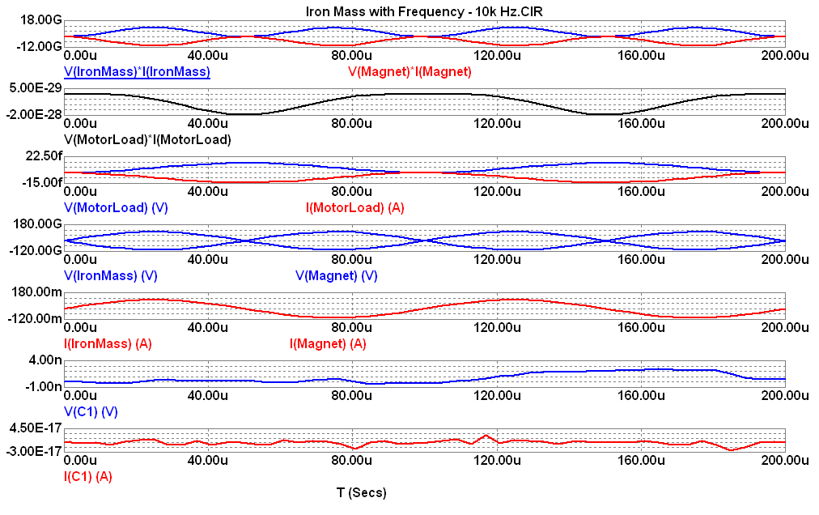
Notice how small is the output? So, according to Micro-Cap, using a frequency input of a current source doesn't help. And I'll bet you that a lower frequency won't be any different than no frequency. So, I won't bother to simulate that condition to find out.

Nodal voltages...

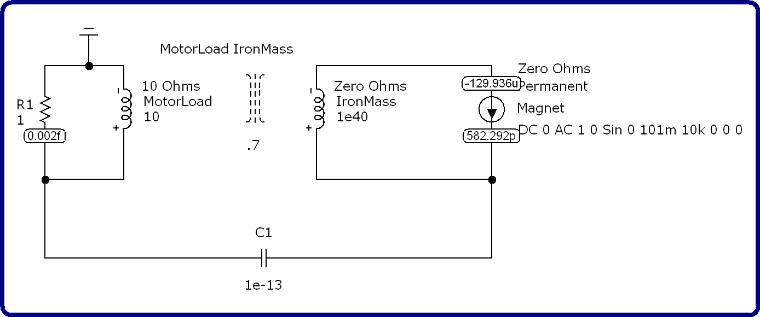

Schematic...
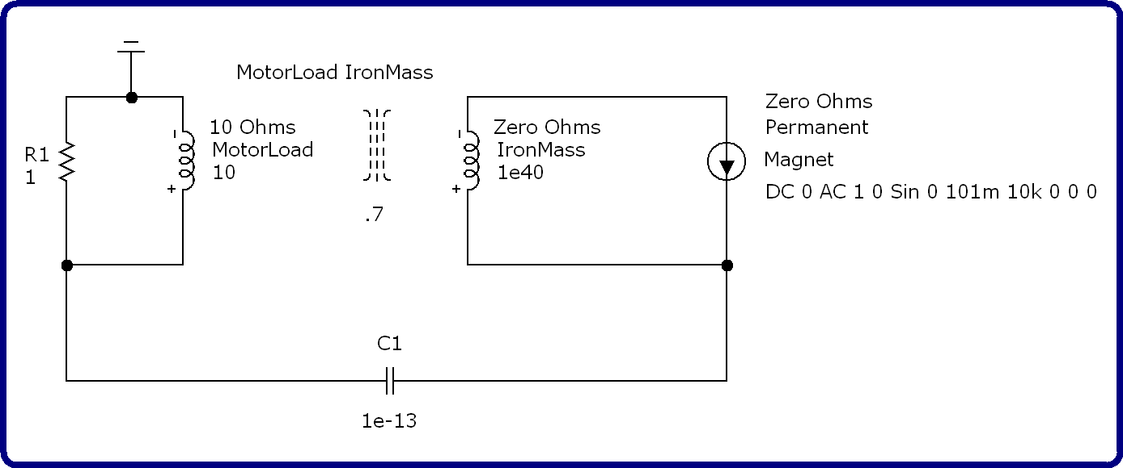

Let's make a comparison between the simulation, above, versus a simulation without any input of a frequency. This is intended to imply that a permanent magnet is attached to a very large iron mass setting up D/C eddy currents sufficiently strong enough to transfer their magnetizing force over to the Motor Load via a magnetic coupling of 70%...

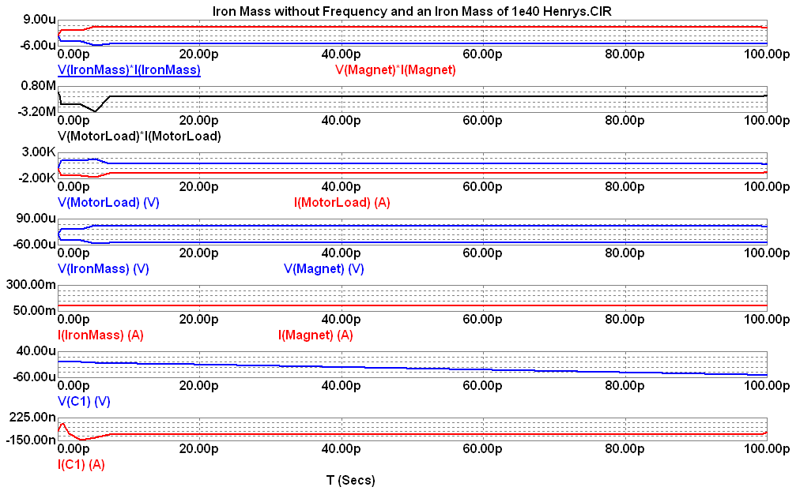
Here are the numeric output data...
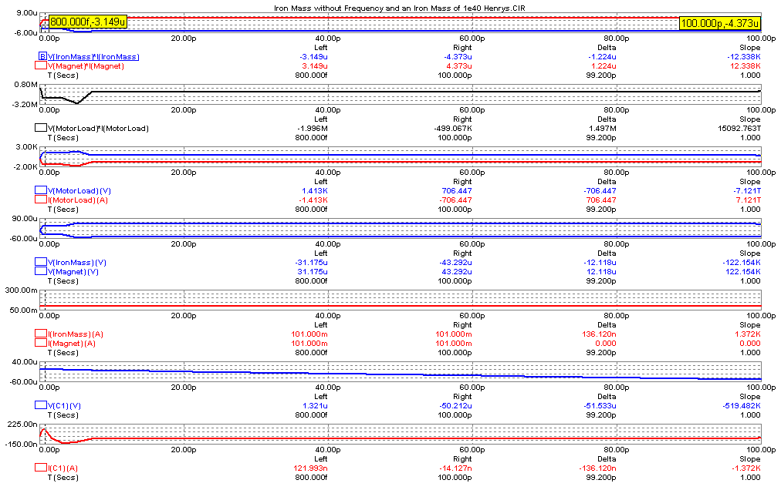
And here are the nodal voltages...

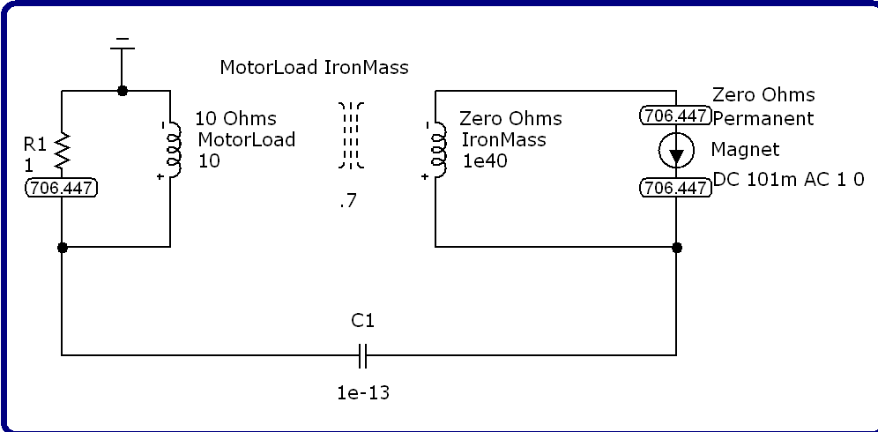

Here is the schematic...
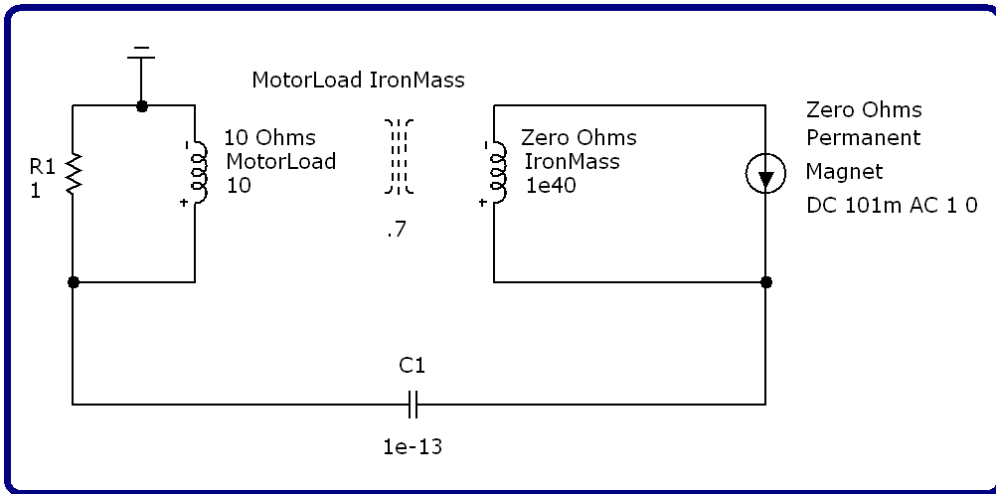

Now, let's turn our attention to the elevation of the inductance, and the mass, of that chunk of iron to an inductance of 10⁷⁰ Henrys...

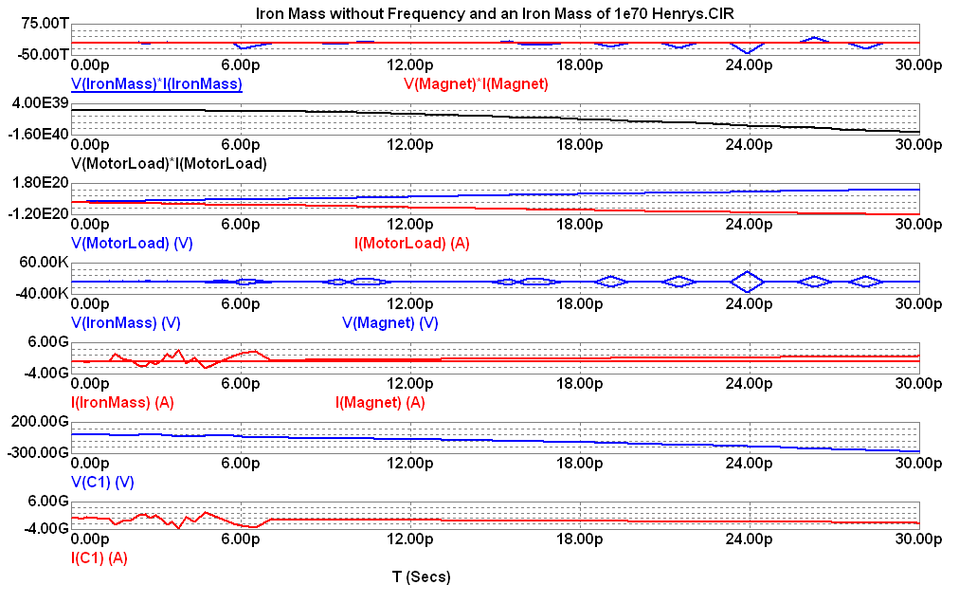
Nodal Voltages...

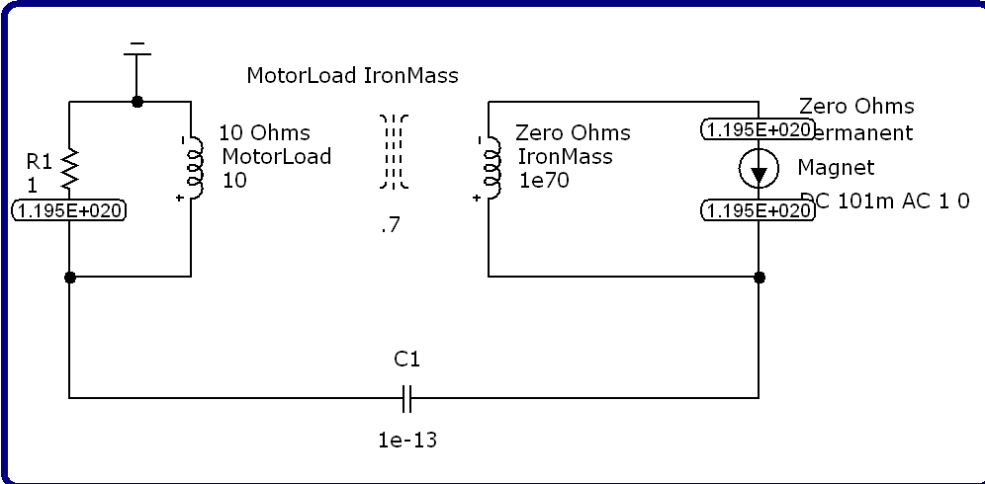
Schematic...

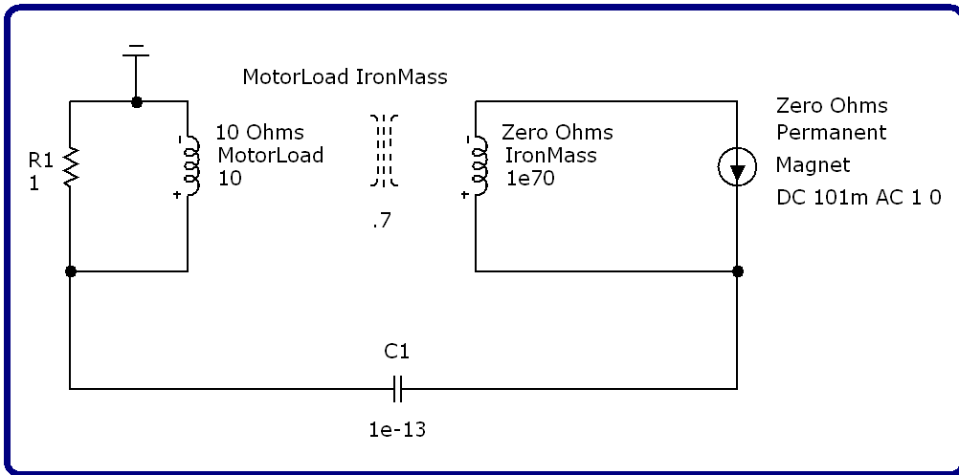

Now, let's go in the opposite direction and reduce the Henrys of the Iron Mass to 10³⁵...
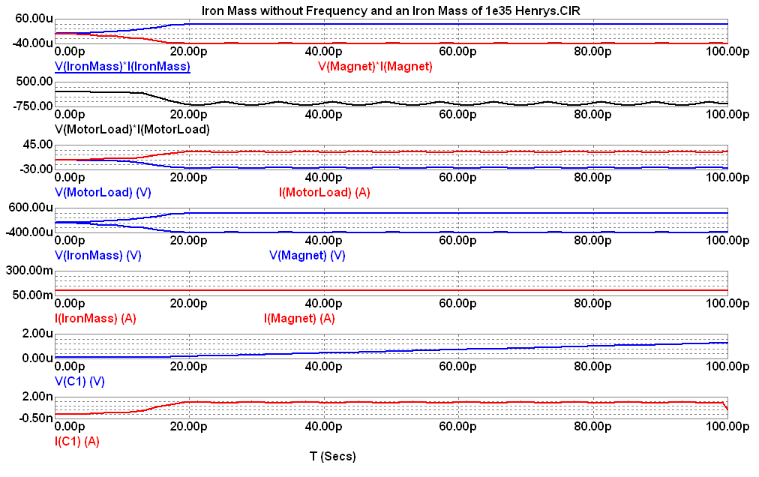
Nodal Voltages...

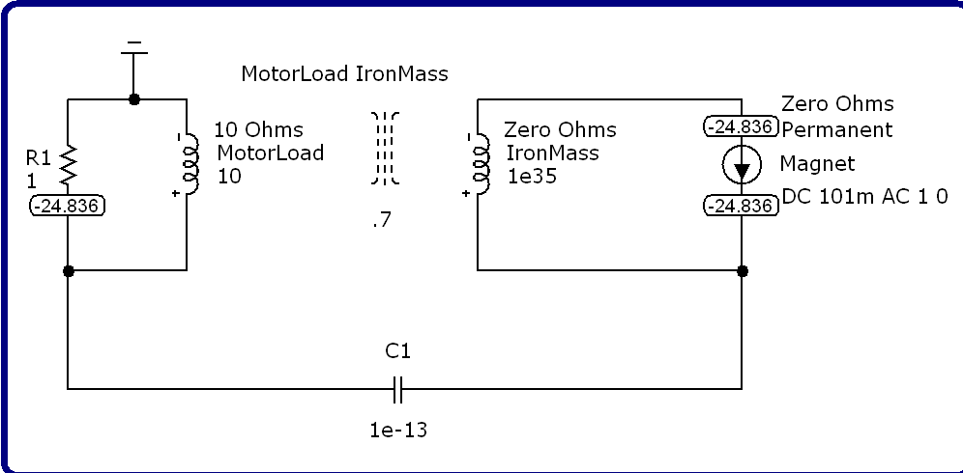

Schematic...
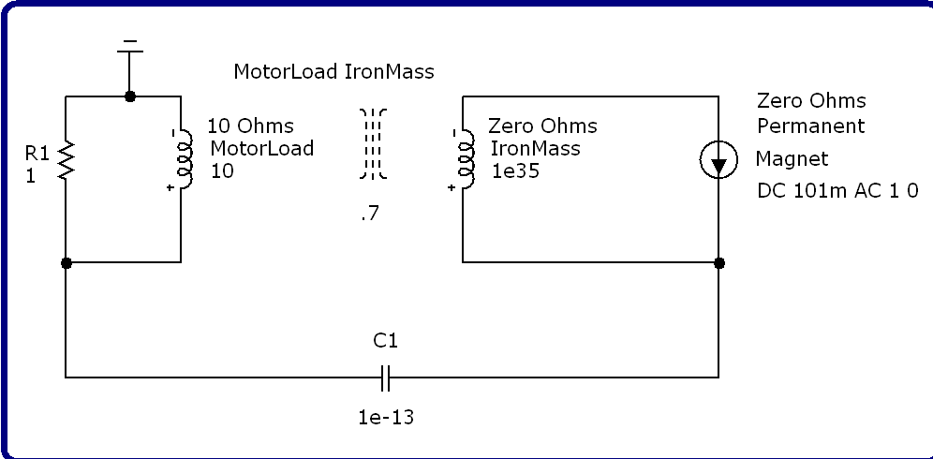
That might be fine and dandy for powering a humongous motor load, but what about powering a pair of white LEDs?...

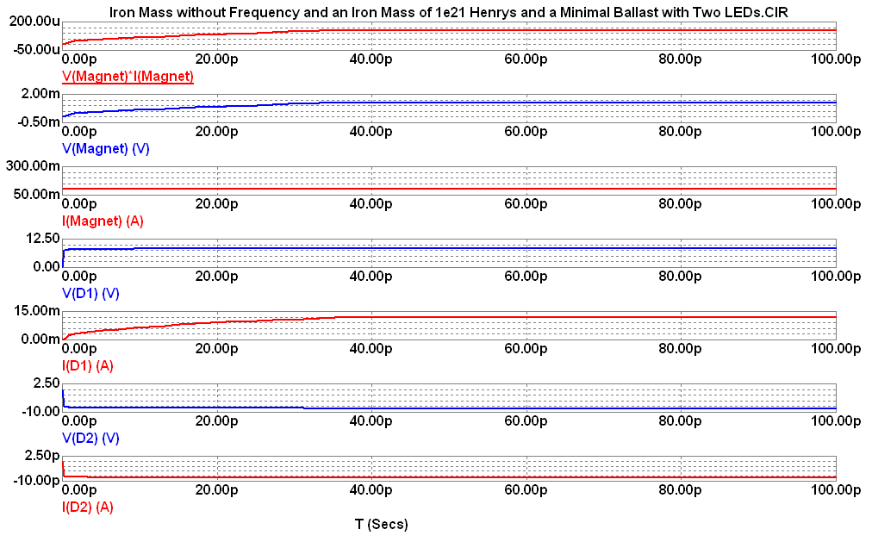

Numeric output...
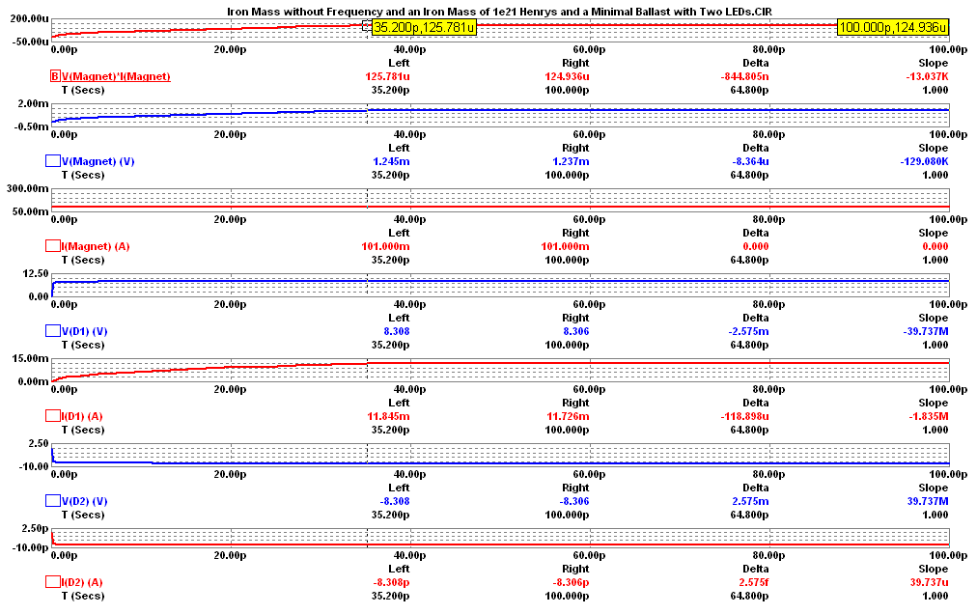
Nodal Voltages...

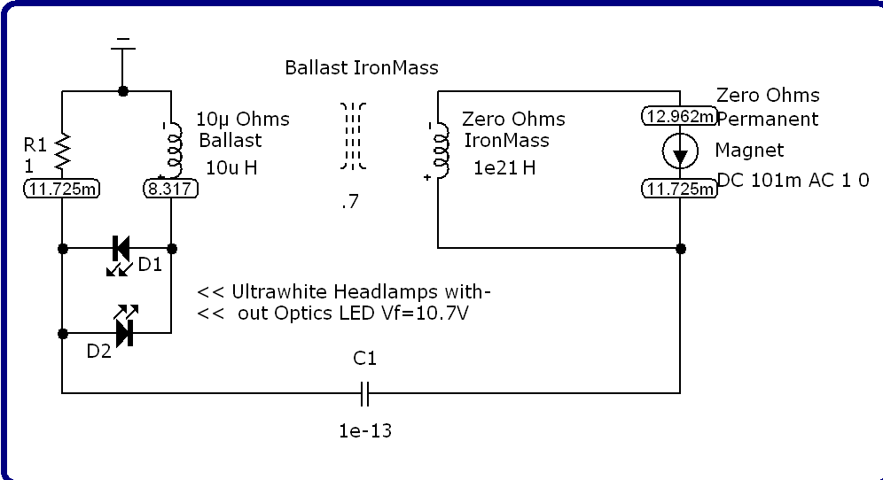

Schematic...
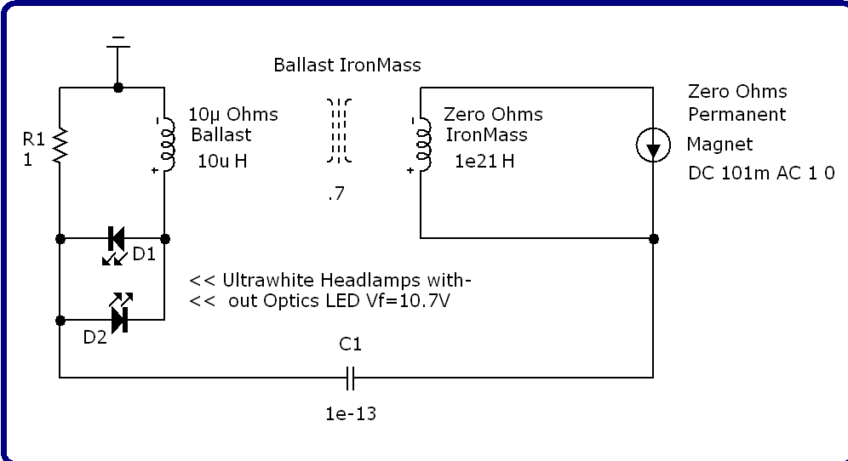
That about wraps it up! Hope you enjoyed this...

