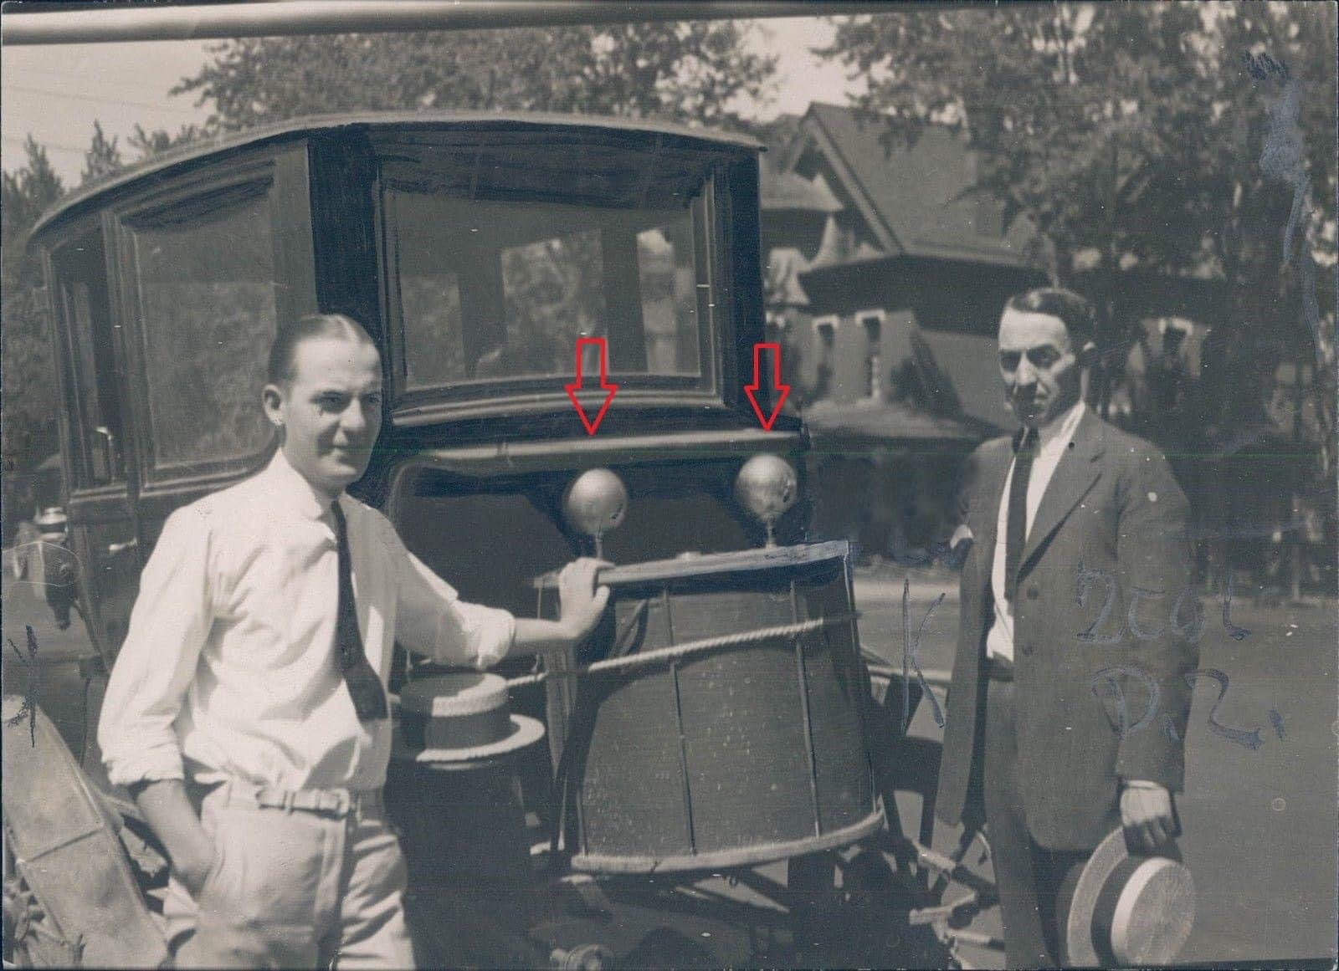
http://vinyasi.info/energy/Ammann-newspaper-article-full-size.jpg
https://is.gd/tayeca
https://ufile.io/c9lfdj7i

