Parallel Capacitance defines the Mutual Inductance of Bewley's Archetype and Eric Dollard's Analog Computer in Longitudinal Magneto-Dielectric mode

Eric Dollard introduced me to L.V. Bewley via his analog computer...particularly his analog computer in LMD mode (longitudinal magneto-dielectric modality) in which, instead of looking down the transmission line, we look across the space between its two wires wherein the dielectric force of capacitance predominates over the magnetic force of inductance once we attach more modules to either the left or right side of this central module...
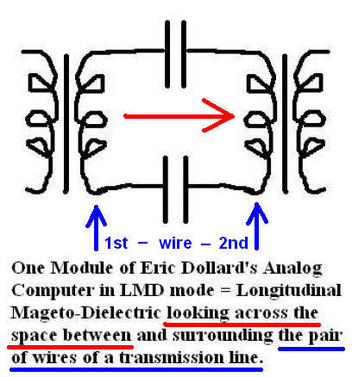
We cause this dominance to occur by how we connect each module, of a multi-module daisy-chain of modules, to either put its capacitors in series and its inductors in parallel if we want it to function in a LMD (longitudinal magneto-dielectric) modality, or else we put its inductors in series and its capacitors in parallel if we want it to function in a TEM modality, namely: a transverse electromagnetic mode. TEM mode is how a normal transmission line operates in which the current travels down the length of the transmission line's two wires and there exists a capacitance between them.
But in LMD mode, something uncanny happens (if we let it)...capacitance, namely: longitudinal waves, becomes the mode of travel. Instead of voltage deteriorating over the length of this type of network, it increases as Eric demonstrates in this video from the 1980s...
https://www.youtube.com/watch?v=6BnCUBKgnnc
If we arrange his analog computer in a LMD mode, then an interesting artifact comes to mind...that parallel capacitance within, or closely adjacent to, two or more inductors – which are also undergoing a magnetic coupling between them – is satisfying the design characteristics of Eric's analog computer.
I can say this in all sincerity due to another equivalency which exists between these similarities and (what I like to call) Bewley's Archetype...

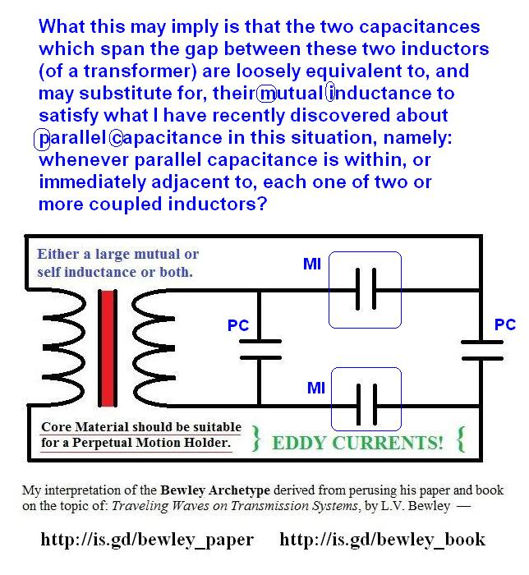
I derived this archetype from referring to Eric's citation of L.V. Bewley as his inspiration for learning about transmission networks at the young age of 16 years while Eric was still in high school.
Bewley wrote at least two, or three, treatises on this subject (that I know of which are available on the Internet) called: Traveling Waves on Transmission Systems...

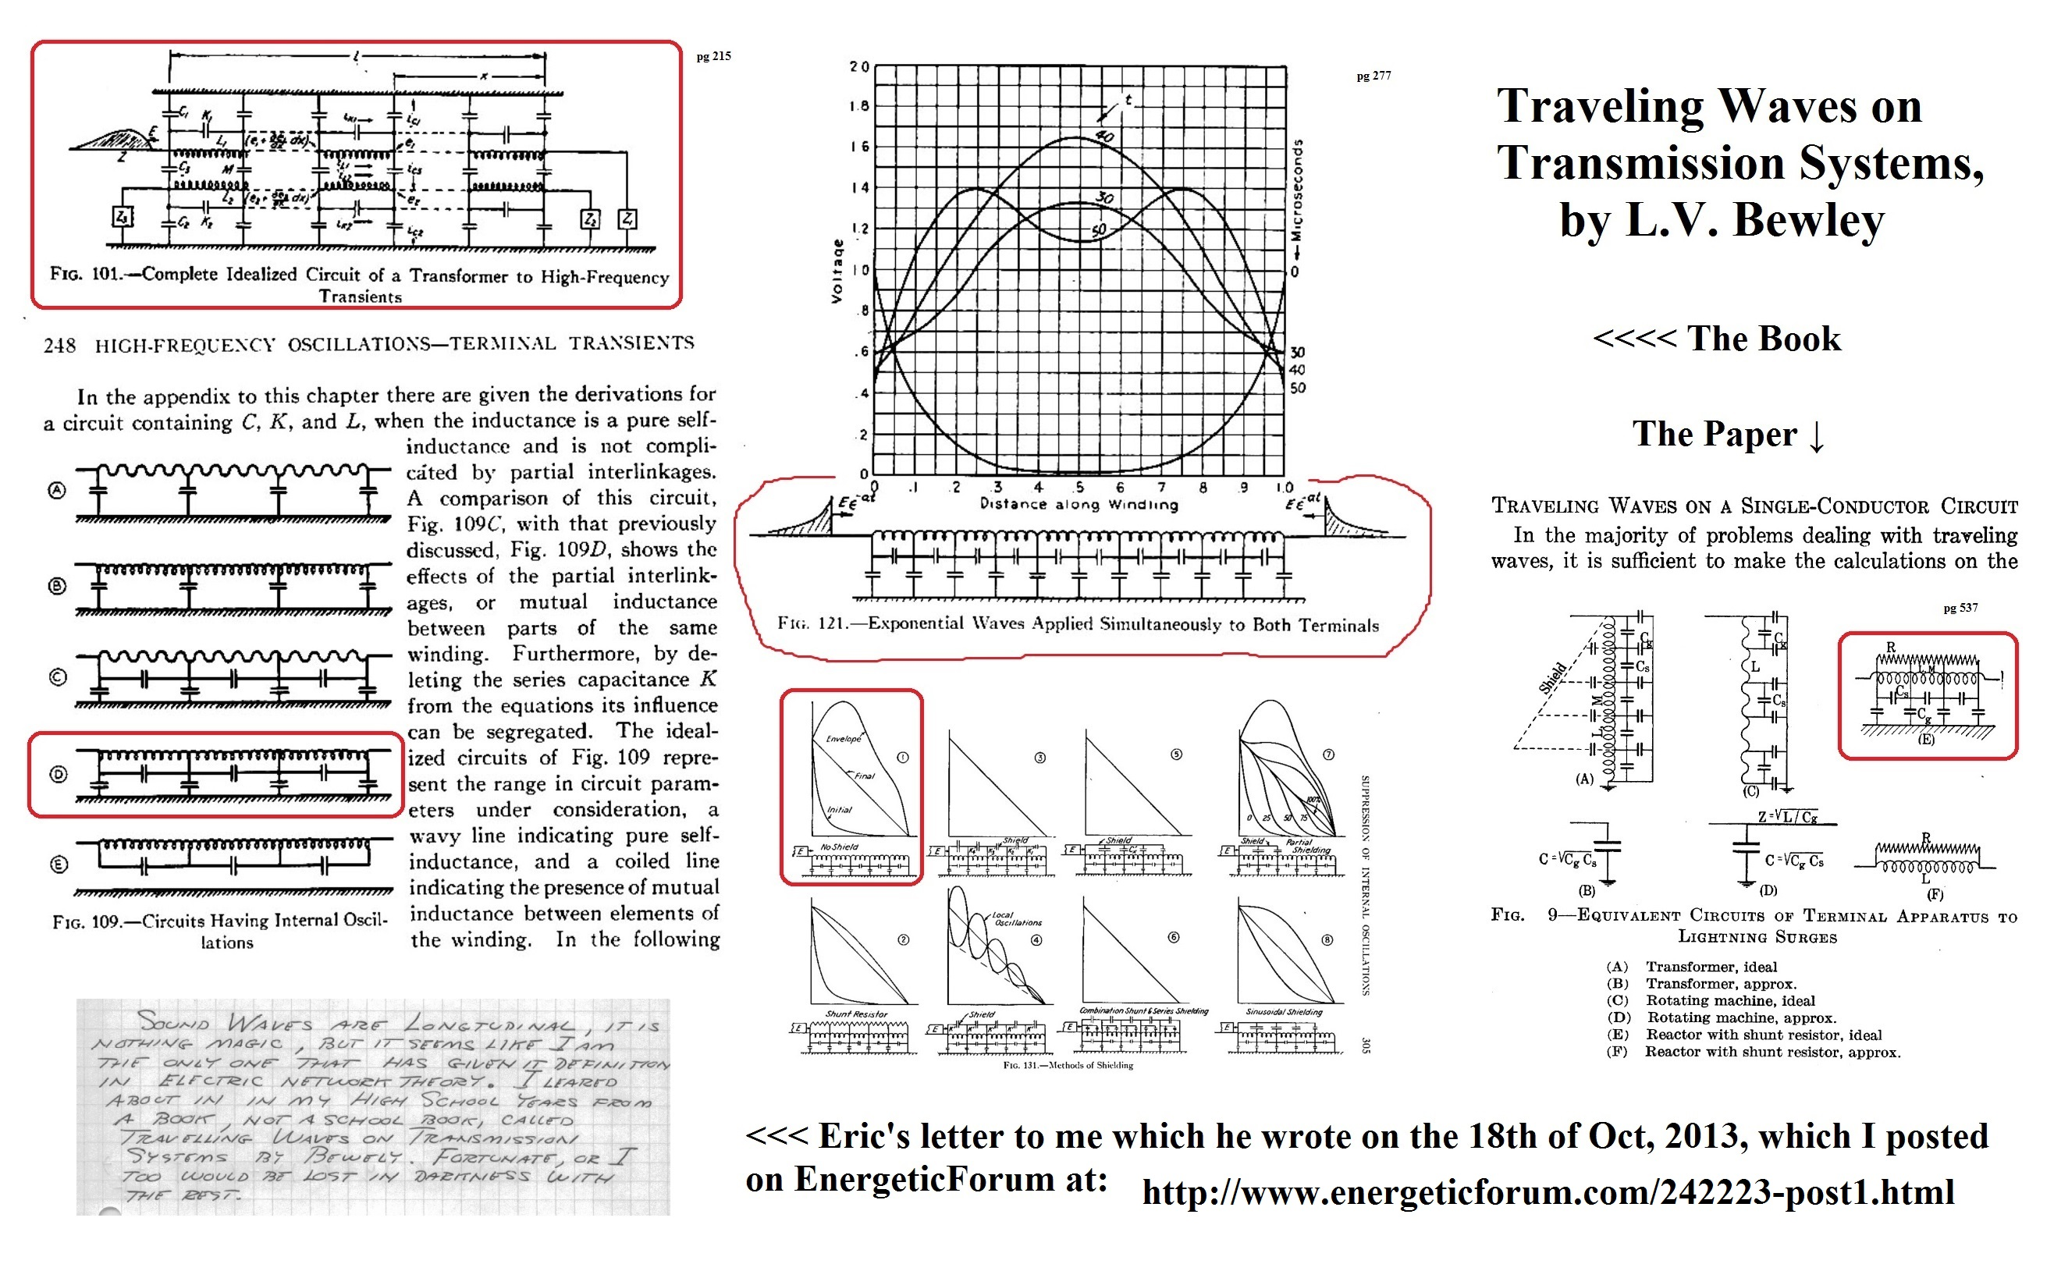
http://vinyasi.info/circuitjs1/texts/Parametric%20Excitation/Travelling-Waves-on-Transmission-Systems_19pg-paper_LV-Bewley.pdf – 1st copy of paper.
http://vinyasi.info/circuitjs1/graphs/Traveling%20Waves%20on%20Transmission%20Systems,%20Bewley,%20paper.pdf – 2nd copy of paper.
http://vinyasi.info/circuitjs1/texts/Parametric%20Excitation/Travelling-Waves-on-Transmission-Systems_332pg-book_LV-Bewley.pdf – 1st copy of book.
http://vinyasi.info/circuitjs1/graphs/Traveling%20Waves%20on%20Transmission%20Systems,%20Bewley,%20book.pdf – 2nd copy of book.
http://vinyasi.info/circuitjs1/texts/Parametric%20Excitation/Travelling-Waves_Transients-in-Transmission-Lines_ppt_LV-Bewley.ppt – only one copy of Bewley's power point presentation.
I derived this archetype by folding one of Bewley's networks of a transmission line along its ground plane, turning the ground plane into a grounded resistor, and creating a mirror image on the other side of this imaginary ground plane. Then, I removed this ground plane, because (under simulation) it didn't need to be there. This left four capacitors in a ring with two inductors in parallel with two opposing capacitors. Then, I joined the two inductors together to become a transformer...

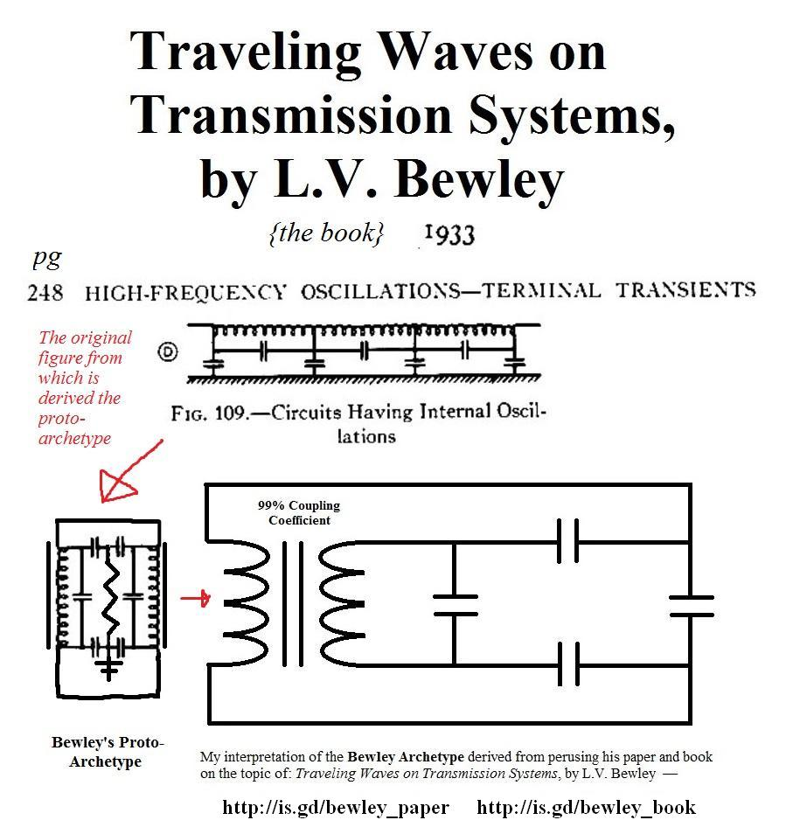
It works quite well as an overunity type of circuit.
Many variations are possible...

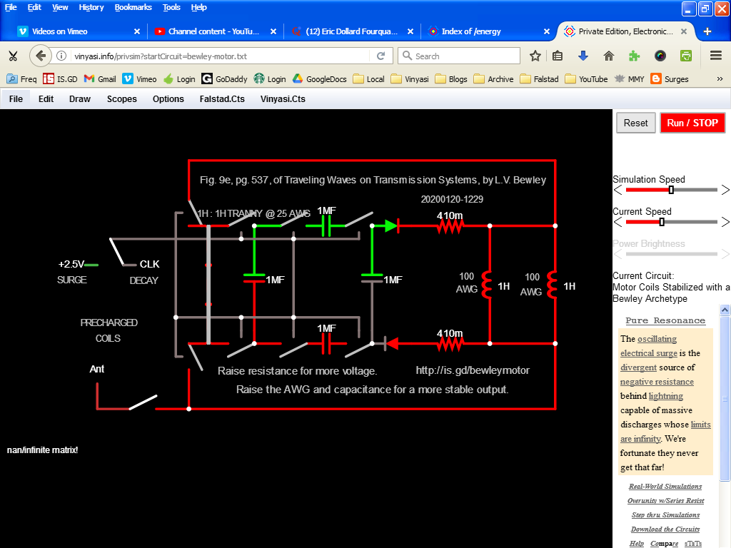http://vinyasi.info/privsim?startCircuit=bewley-motor.txt

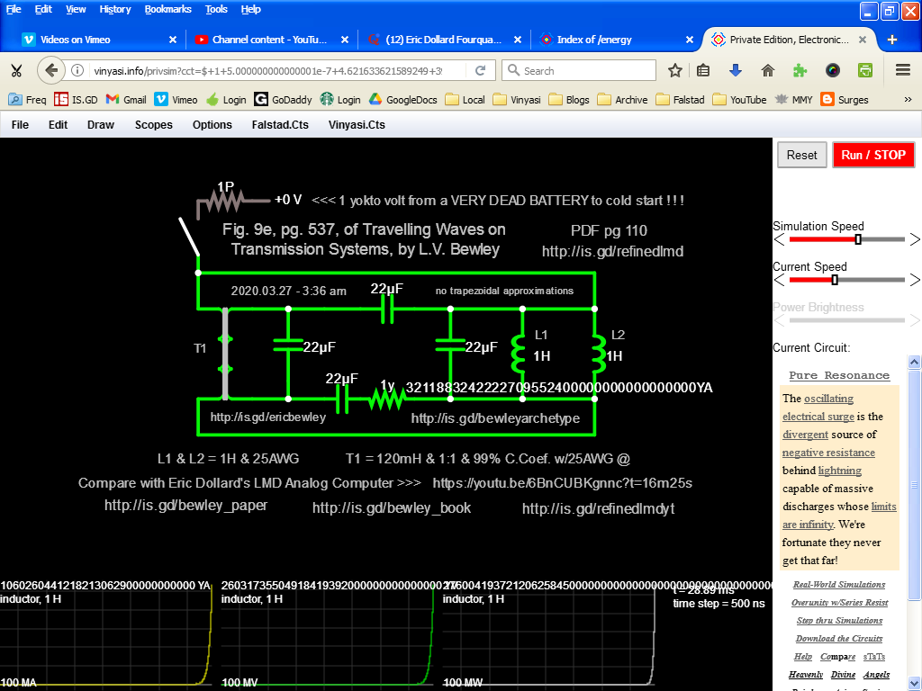http://is.gd/bewleyarchetype
Here's one in LTSPICE using a Chan model for a non-linear idealized transformer which epitomizes the use of a “hard magnetic (transformer core) material” suitable for encouraging eddy currents which is useful if you're doing “perpetual motion holder” (magnetic remanence) experiments (popularized by Edward Leedskalnin, but invented almost a century earlier by someone else)...

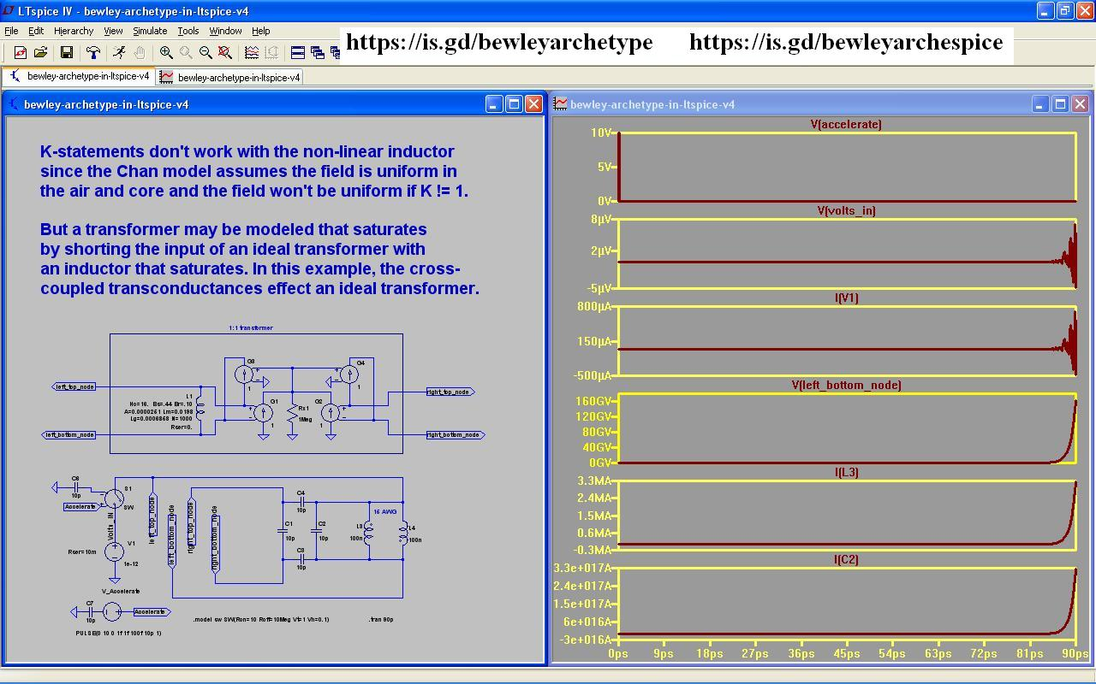https://is.gd/bewleyarchespice
https://vimeo.com/594112790
https://youtu.be/F2yEML5h5cI

http://vinyasi.info/circuitjs1/texts/Parametric%20Excitation/Parametric%20Excitation%20of%20Eric%20Dollard's%20Analog%20Computer.pdf = https://is.gd/kiwiji

