Suppression of a Surge

This is a perfect example of Ohm's Law in action, namely: how to suppress a surge is how we conventionally think in the world of today: we give a circuit everything it needs to survive by assuming that it cannot fend for itself.
In other words, we ignore Lord Kelvin's suggestion of using the “Mho” to designate admittance and ignore whatever this may imply, such as: taking the multiplicative inverse of Ohm's Law and negating it for general guidance on how to encourage free energy (freely available reactive power).
But, if we want free energy, then we give a circuit an initial charge from a precharged capacitor of a level of voltage no different than our immediate environment. This just happens to be what crystal radio sets from 100 years ago were powered by the same amount of voltage, ie. a couple of microvolts. Then, we stand back and wait patiently for the development of a surge. And if we're lucky, then we won't have to wait too long. But if we're slightly lucky, then we'll have to wait a long, long time. And if we're not lucky, then we'll have to rethink our strategy until we get a surge to materialize.
I've had to suspect many things whenever hypothesizing what the Ammann brothers may have done, or may not have done.
In this scenario, I'm guessing that the car's antenna is serving as a microvolt input to suppress the initiation, and maintenance, of a surge within their circuitry...a sort of ON and OFF switch which, if pulsed, could average out to whatever level of power they desired to supply their car's electric motor (within the tolerance which it was designed to endure). An extremely low-frequency crystal radio could also be used, but is not required by this simulation. The antenna is good enough to suppress a surge as far as LTSPICE is concerned.
In contradistinction to the whip antennas continuously supplying a voltage input which suppresses surges from developing or maintaining themselves, the two precharged capacitors, C4 and C5, are perfectly adequate for encouraging surges since this input only happens once, quickly dissipates and gets out-of-the-way of the wave mechanics of the evolution of a surge.
This is important… Continuous voltage sources, ie. batteries, etc, are also the simplest of voltage regulators, because they suppress the all-important frequency and wave-form of a surge which must be allowed to develop without any interference. Sometimes, an input of a very low voltage can help a surge if this input is inside of the gas discharge tube of a spark gap. But this example, here, has no spark gaps and, hence, its input of one microvolt from a battery (representing the input from a whip antenna — a piece of wire one yard long) suppresses the development of a surge and wipes out any preexisting surges as well as any future ones.
It is these frequencies of a surge, and the wave-forms of a surge, which spell out — in potential format — the development of a surge. Frequency and wave behavior are potential forms of energy not subject to Conservation; nor are they subject to entropy. Yet, they dictate whether or not a surge will be successful at dwarfing our expectations as to what is possible.
The behavior of these frequencies is oftentimes a complex of one wave riding piggy-back on top of another wave. The base wave may possess a constant amplitude and a constant frequency, but its parasitic wave-form may be of a different shape than the host wave along with an ever increasing frequency and amplitude. Check out this example…
https://i.stack.imgur.com/pg1w1.jpg
Is free energy possible? Yes, if we foster surges…
Surges are delicate instruments easily suppressed by the brute force of our ridiculous presumption to handhold, mollycoddle and forcefully feed our circuitry as if they were incapable of growing up into self-reliant individuals like ourselves.

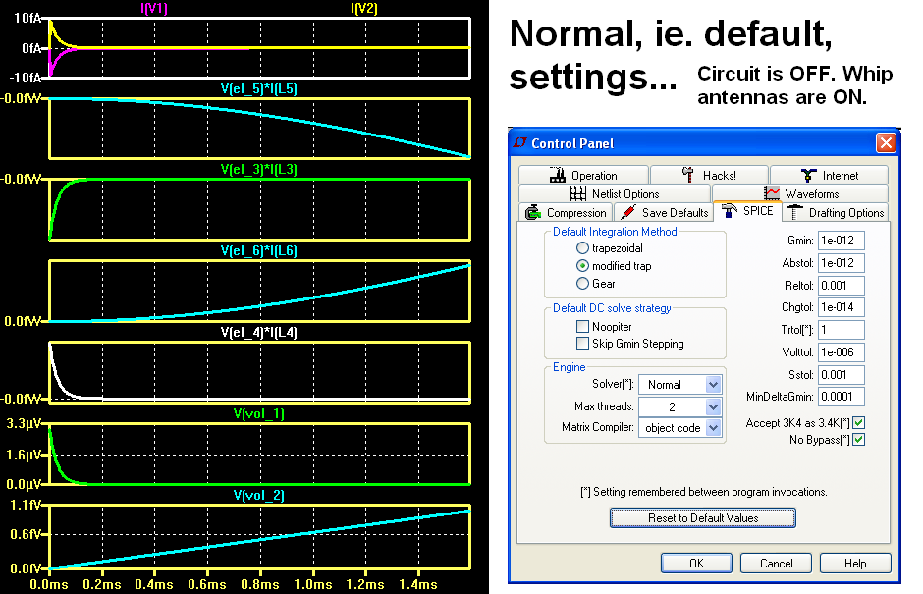
It's interesting to note that I have reverted to the default settings, in Control Panel – SPICE tab. They are good enough for running this software for simulating this version of this circuit concept.
Somehow, the parallel capacitors – adjacent to the coupled inductors – are stabilizing both the circuit and the simulation. This is a good sign...

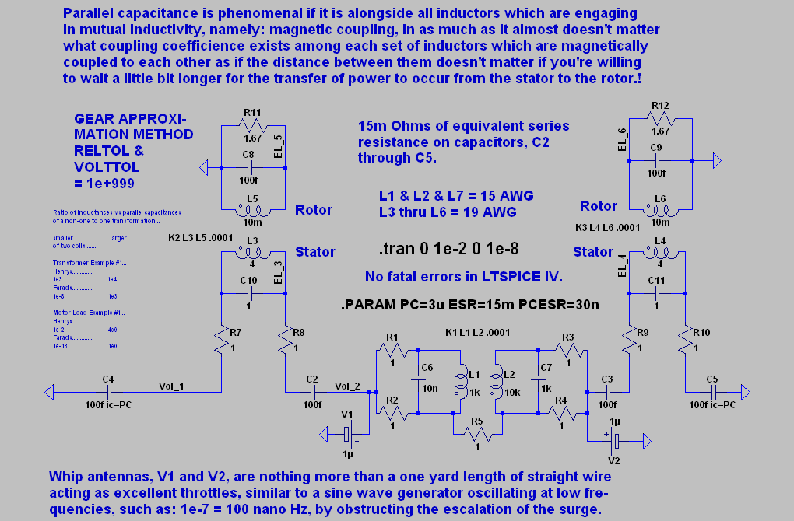

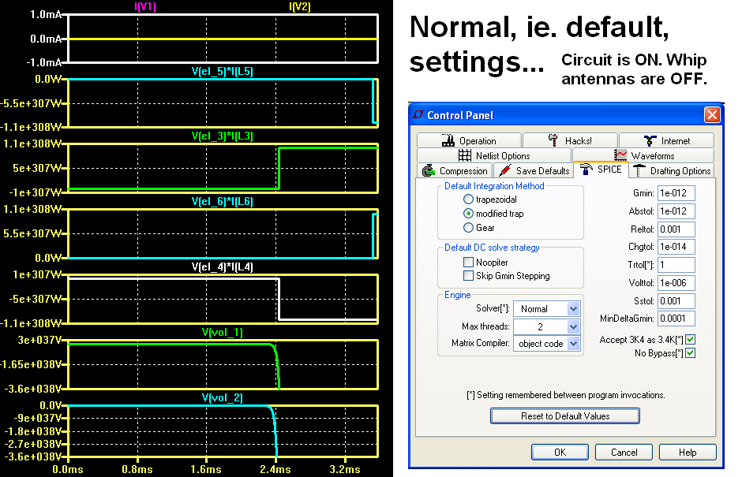

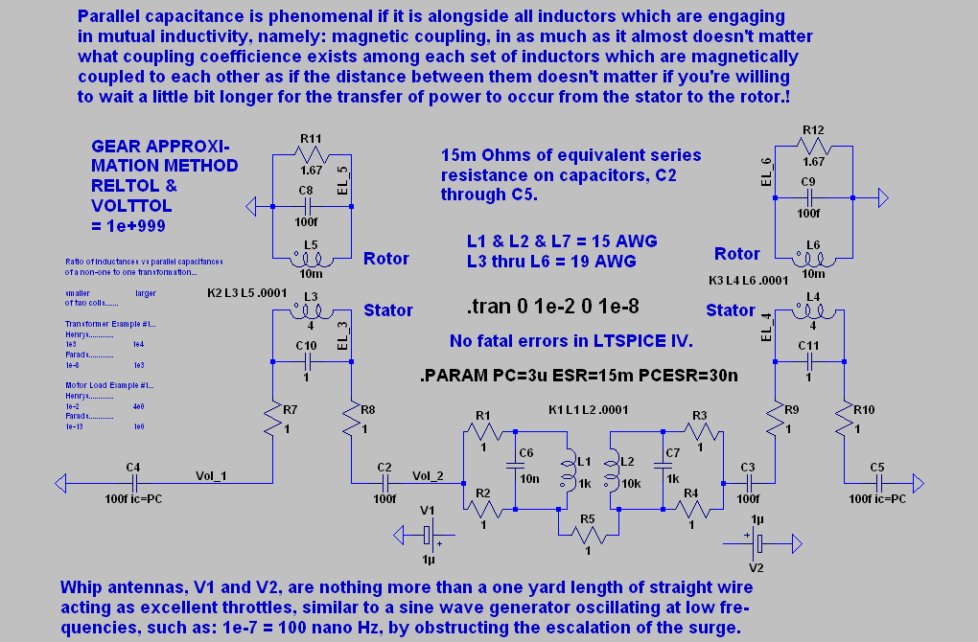
How to suppress a surge and avoid free energy...posted on Vimeo.

