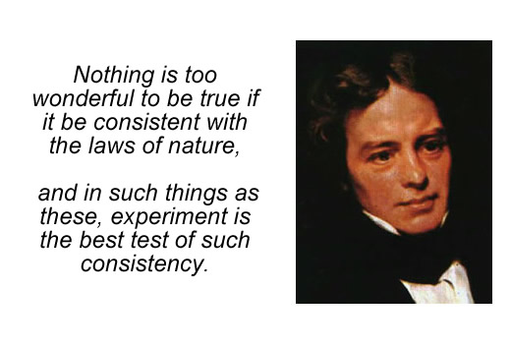

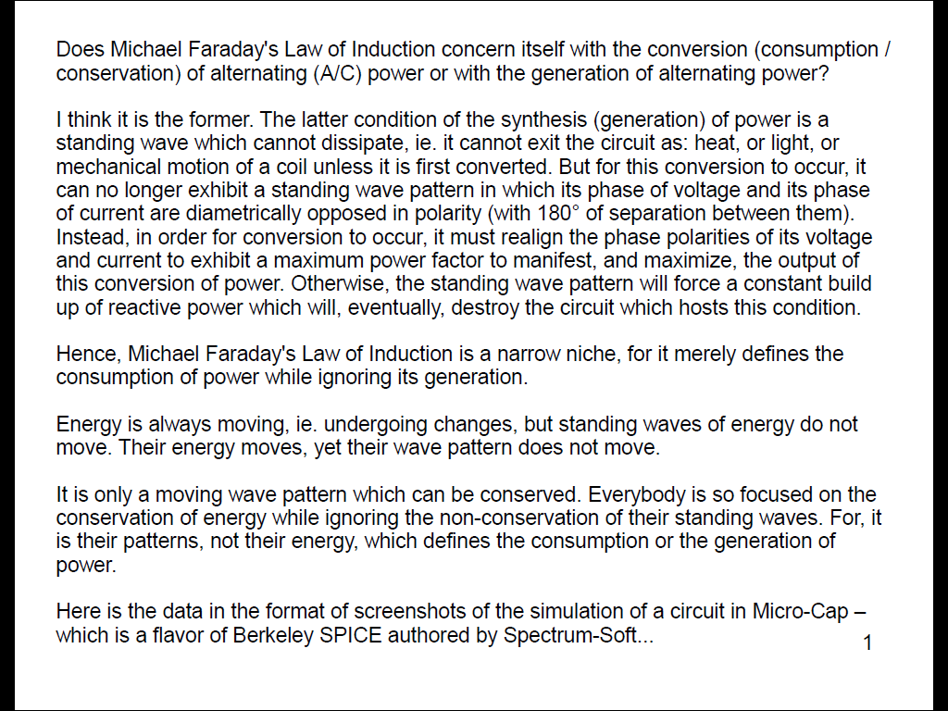
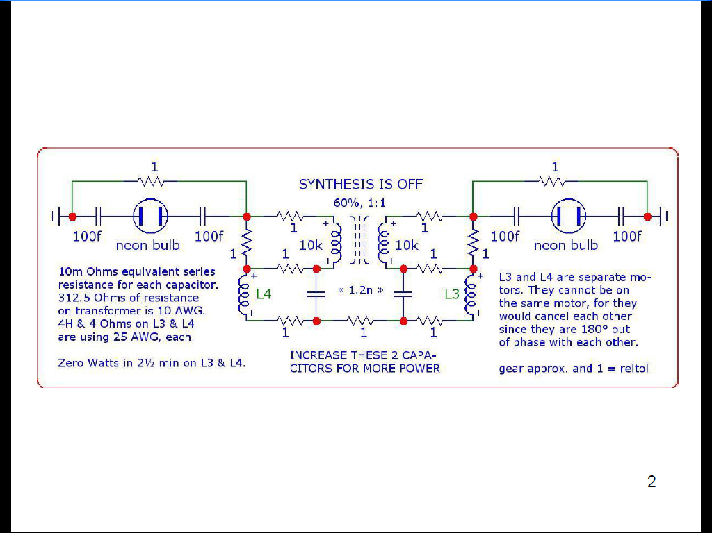
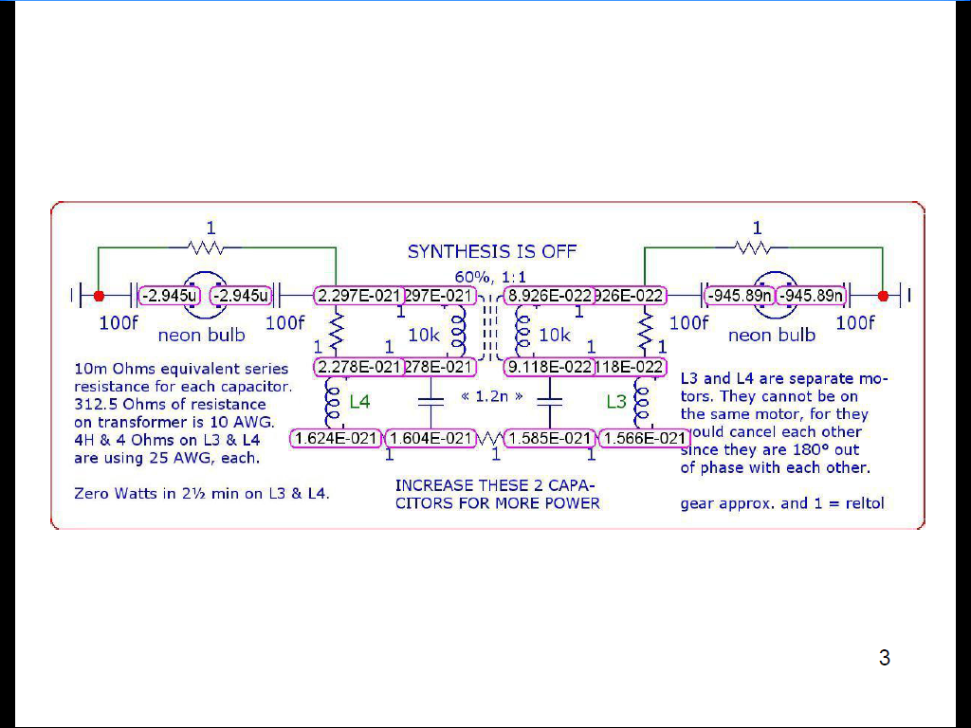
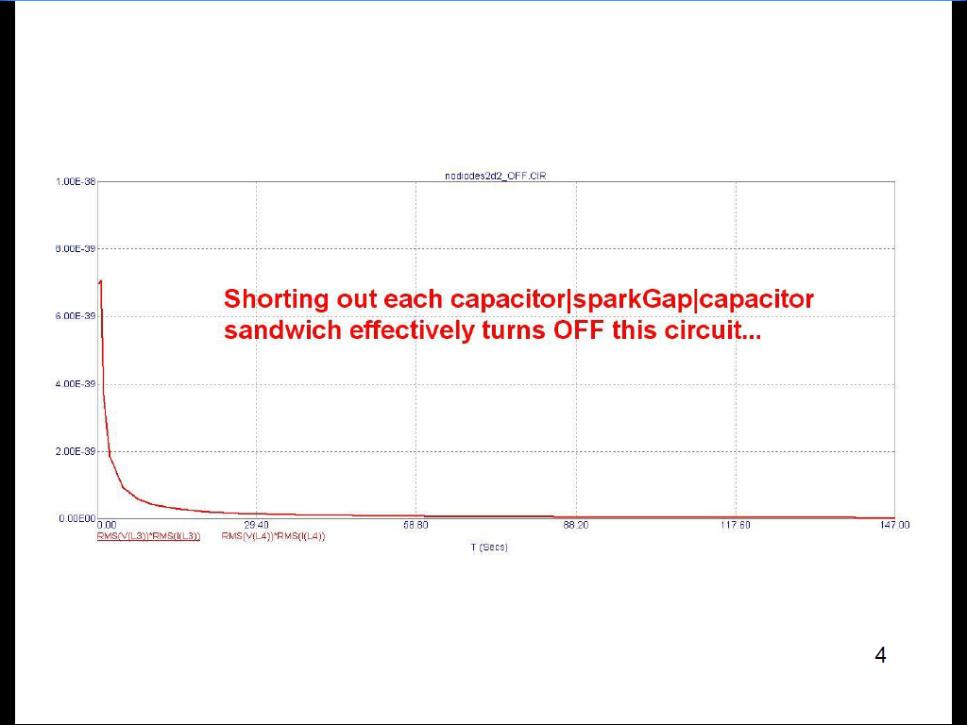
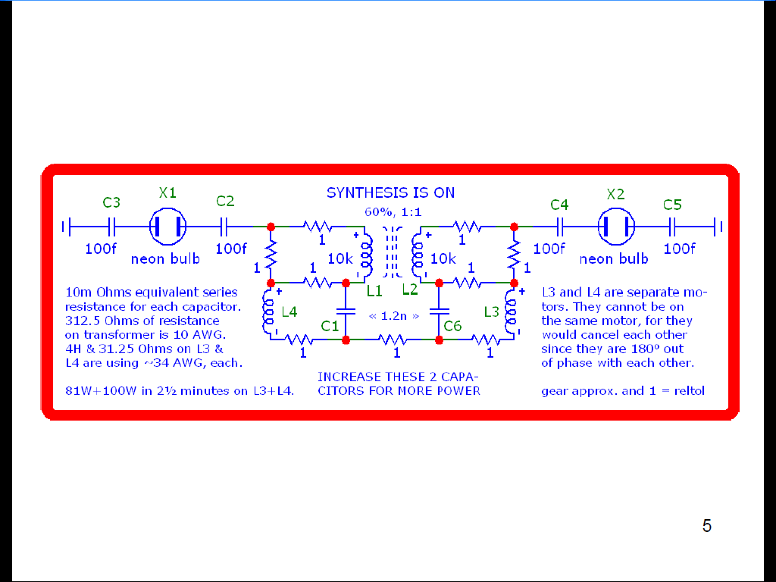
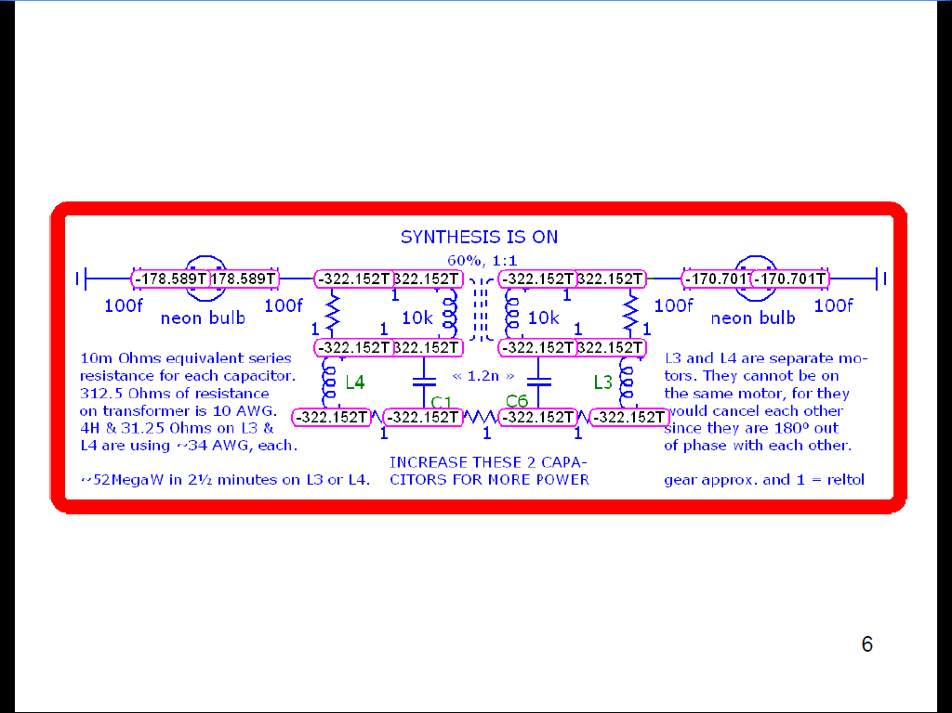
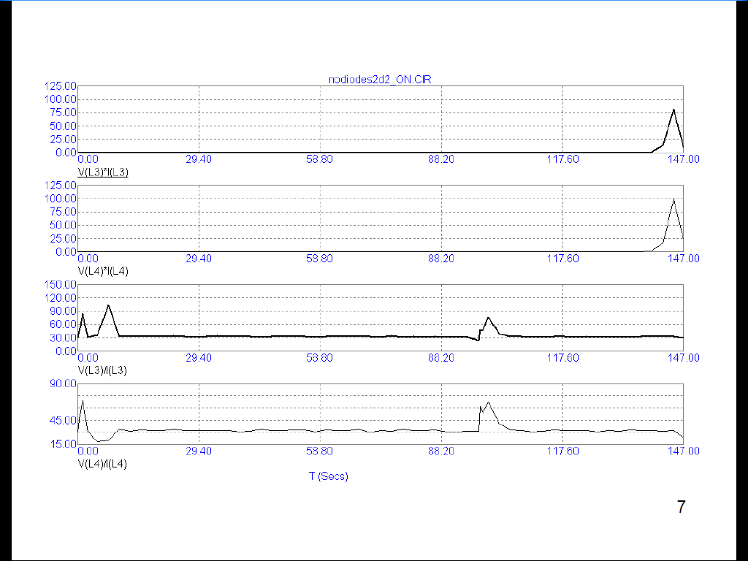
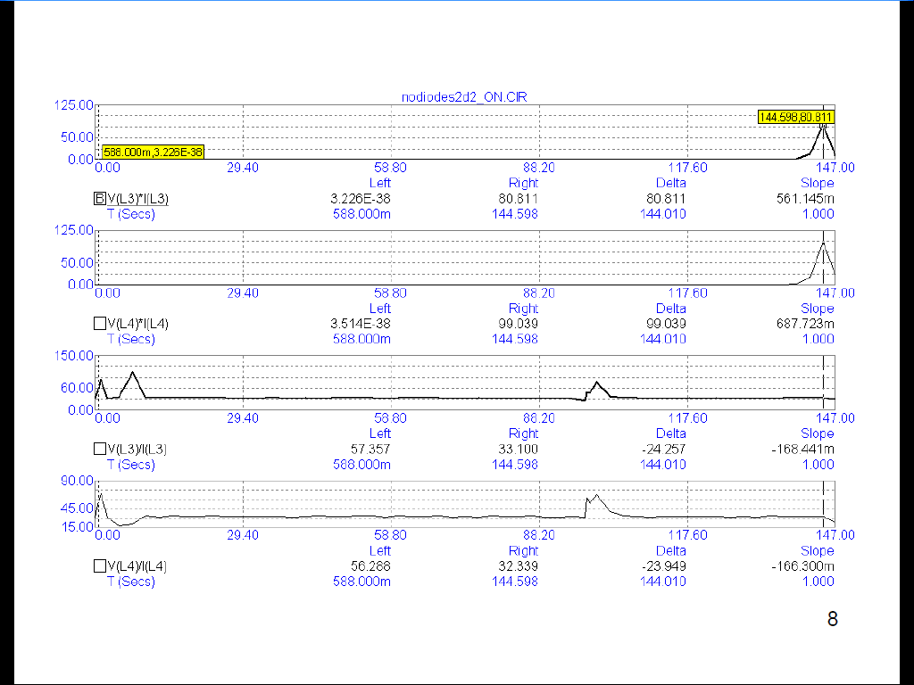
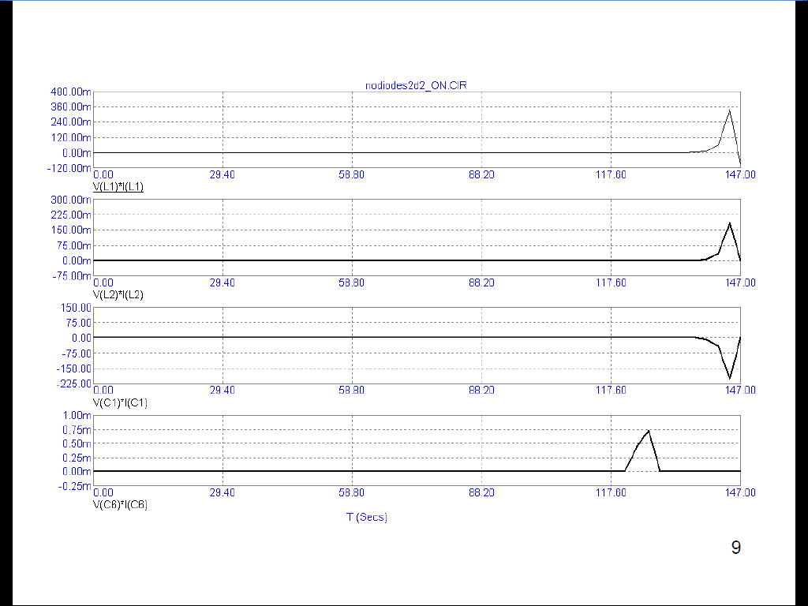
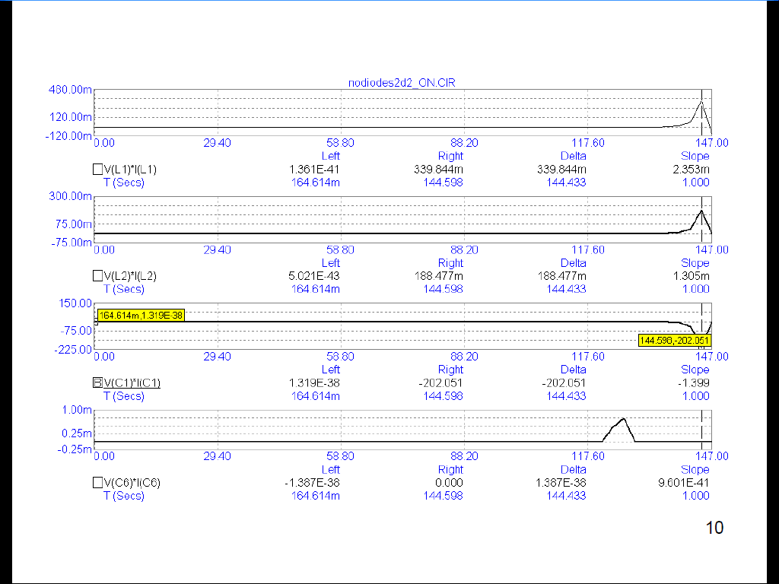
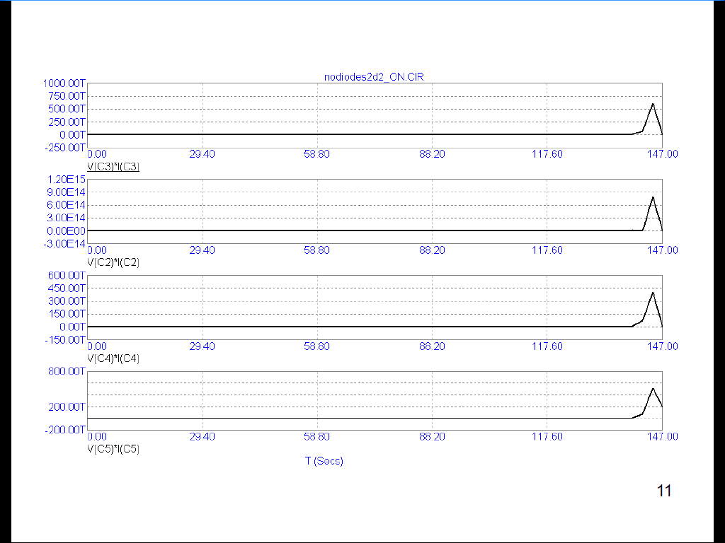
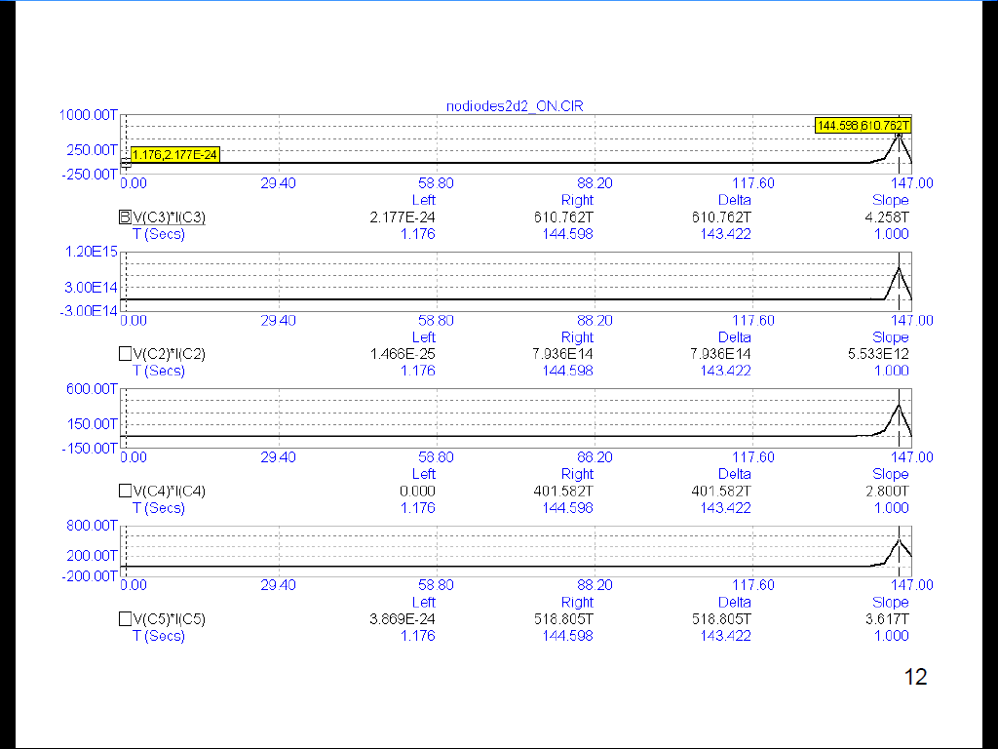
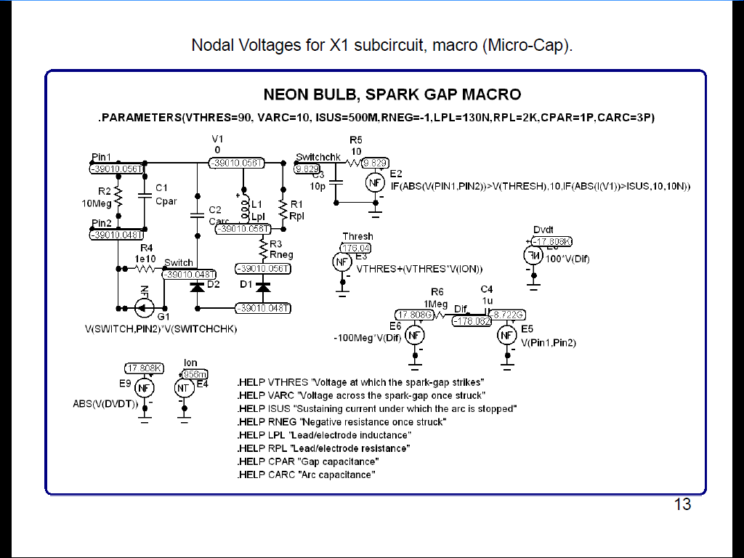
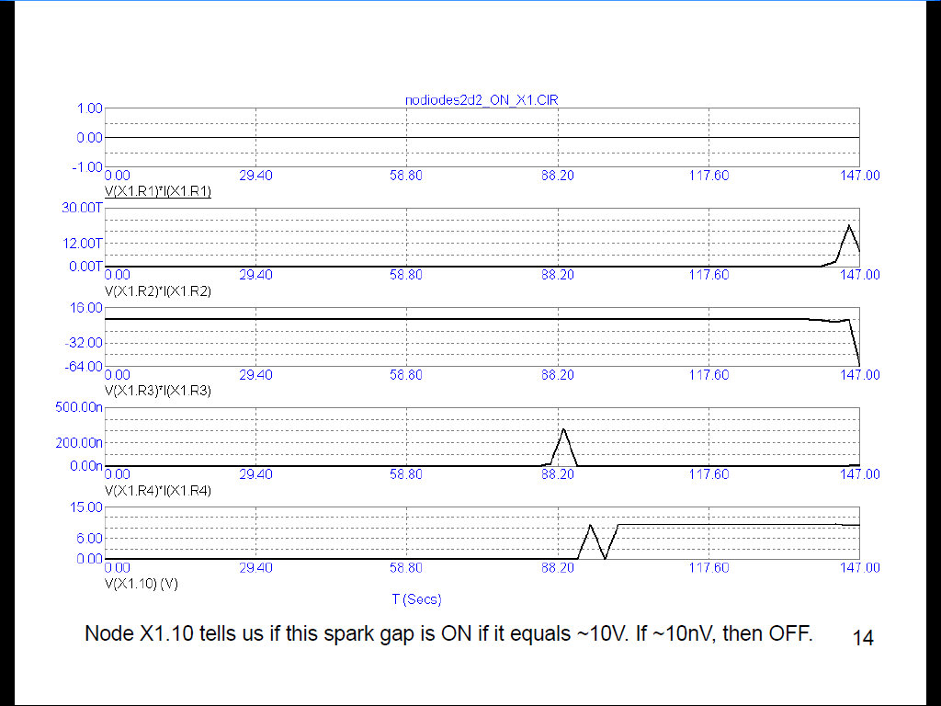
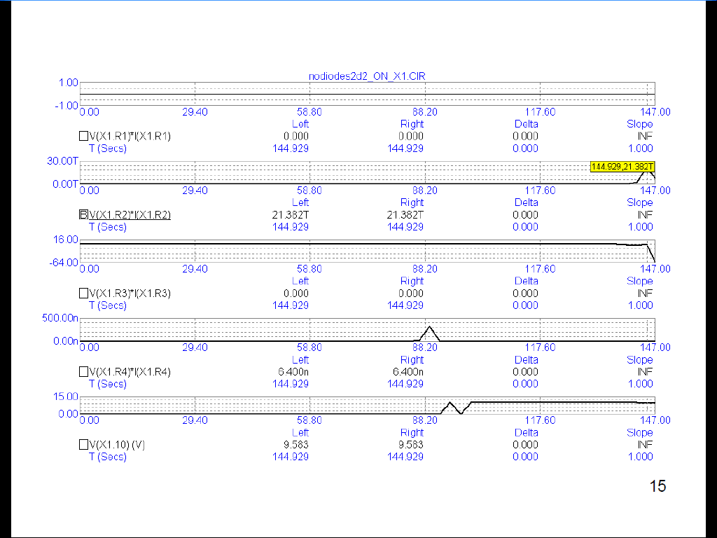
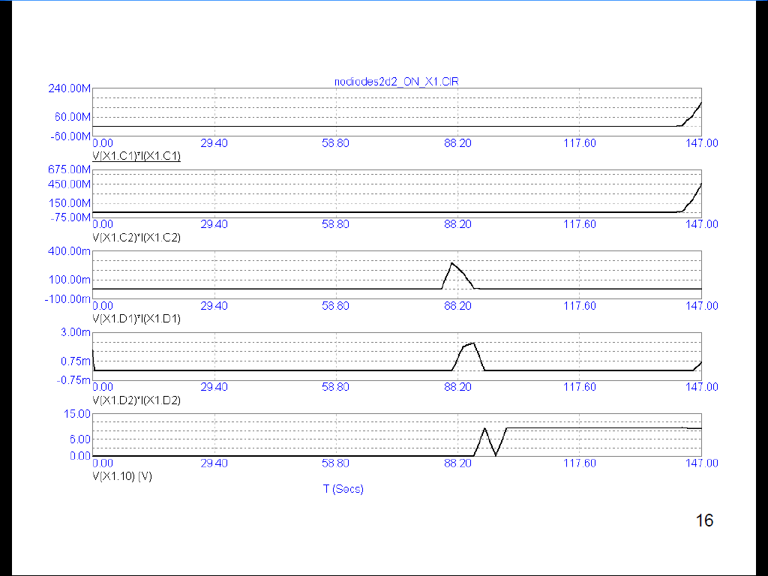
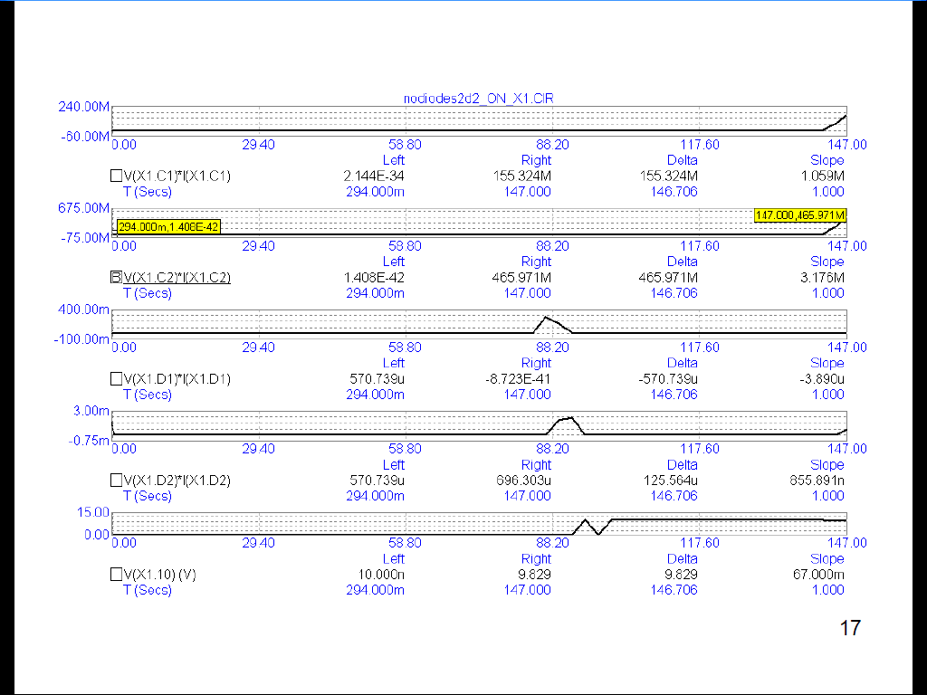
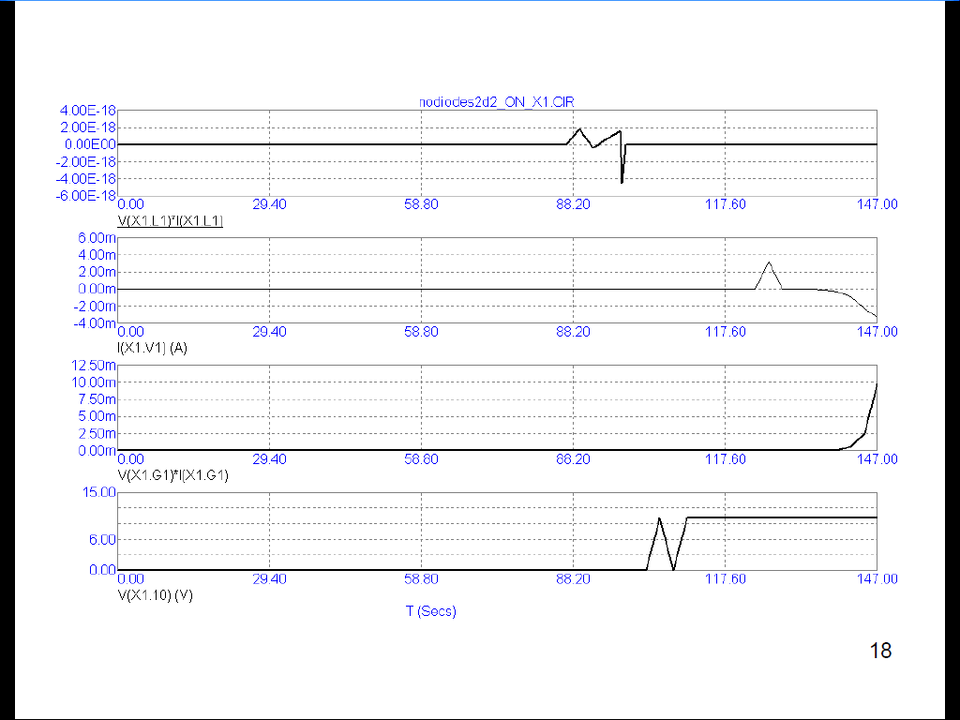
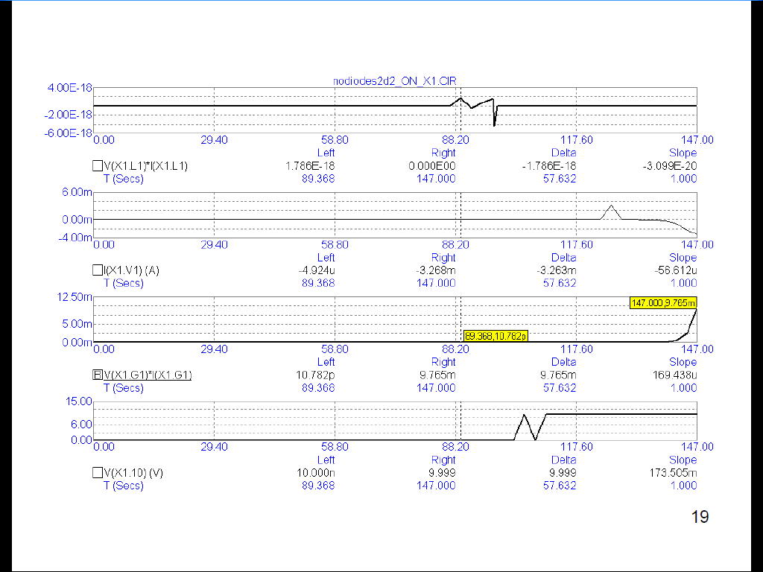
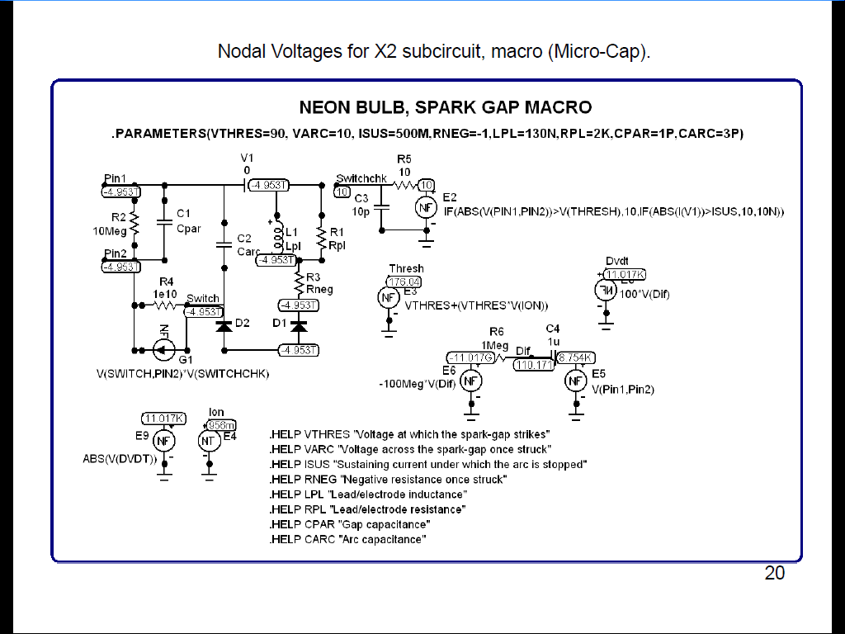
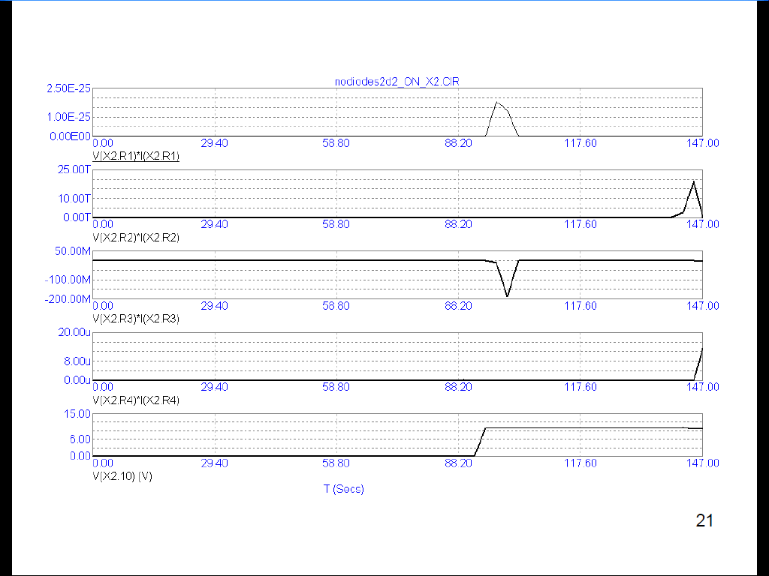
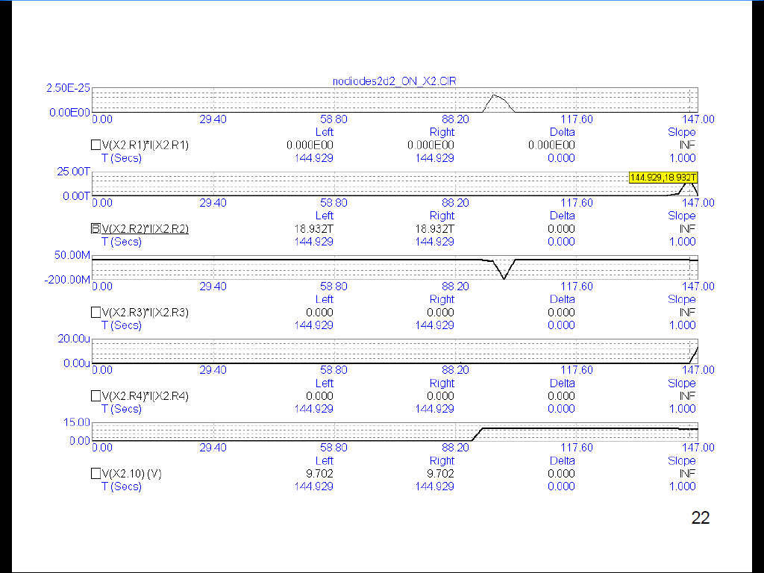
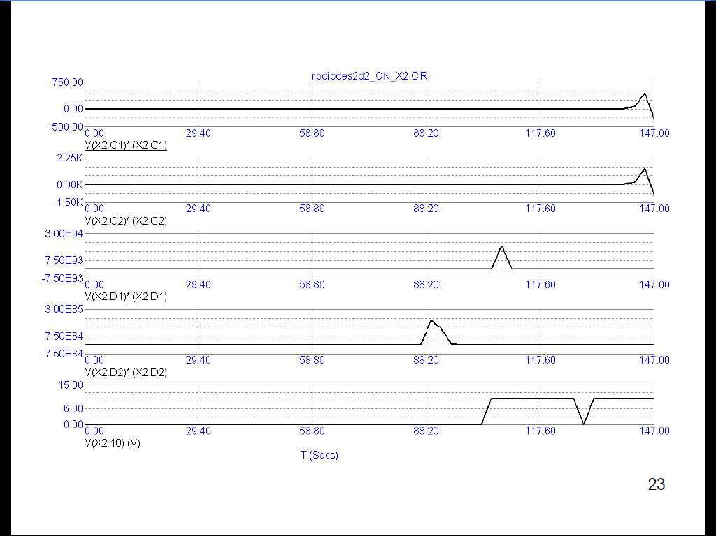
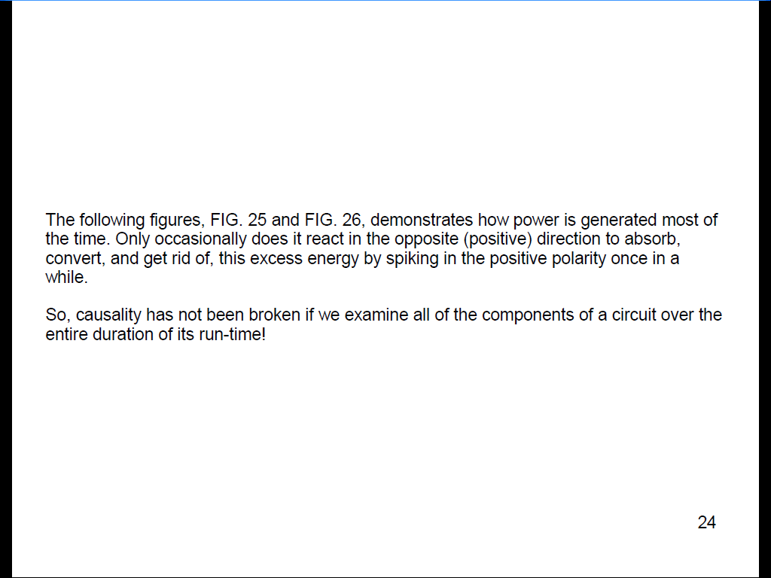
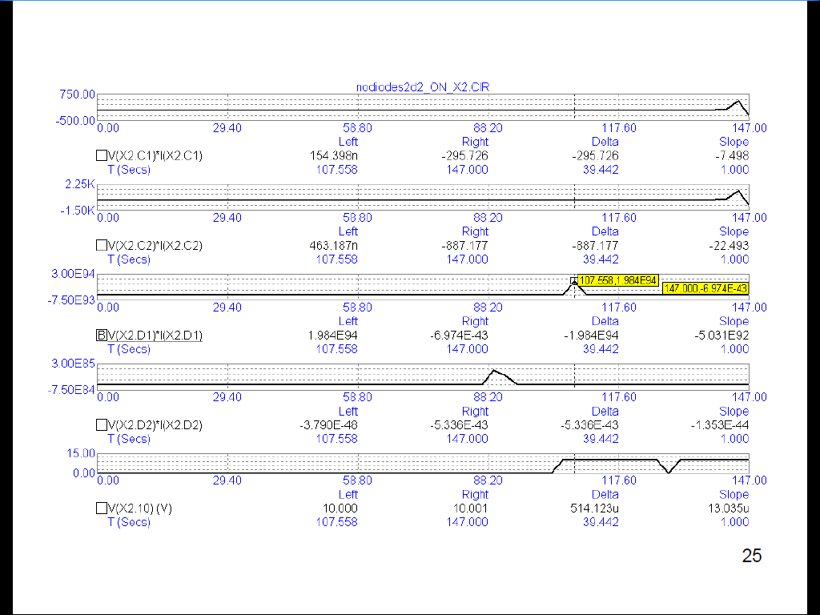
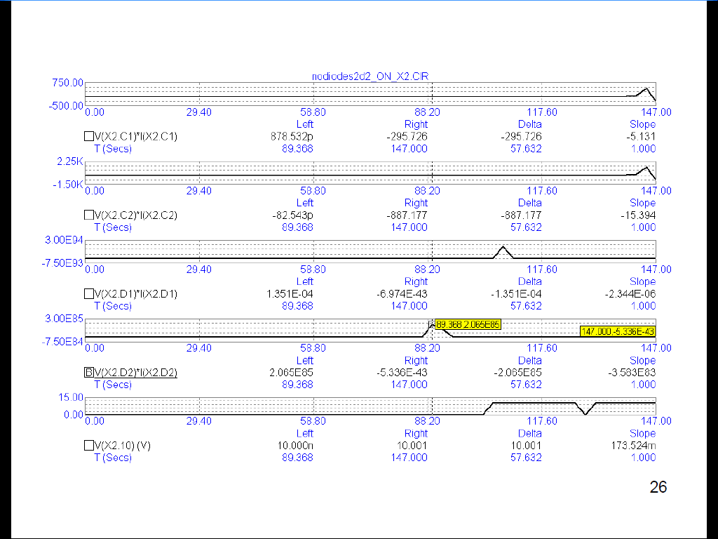
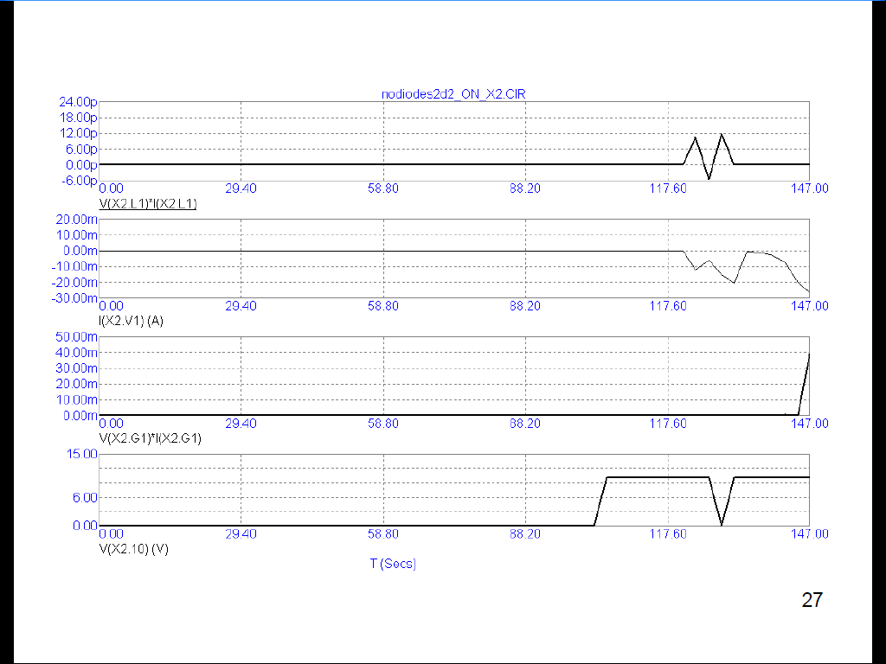
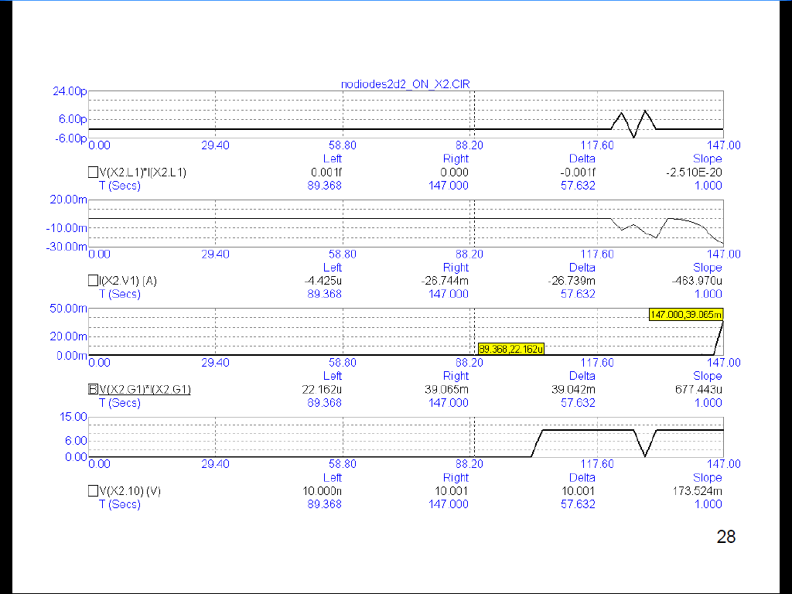
Why do we ignore “free energy?”
Because we are too preoccupied with energy while ignoring wave patterns.
The generation of energy is distinguished by a wave pattern called: a standing wave. These types of waves are rarely studied. They are the heart and soul of “free energy.”
A battery is an example of the conversion of the chemical energy which is stored inside of itself into electrical energy which exits its positive and negative terminals. Hence, it cannot generate energy; it merely converts energy from one format into another format.
The consumption of energy occurs whenever energy is being converted into another format, such as: electrical energy feeding a light bulb is converted into light and is distinguished by a wave pattern which moves. Hence, the battery and the light bulb inside of a flashlight circuit are not designed with the intention to generate power since that would give its owner a certain degree of freedom from having to purchase anymore power if he can generate his own power which he can't generate with a battery and a light bulb.
Yet, the arrangement of various electronic components (such as: capacitors and coils of wire, etc.) can sometimes generate power. And simple resistors, such as: heating elements, can convert the generation of this standing, electrical wave energy into useful heat energy and boil water to run a steam locomotive, or replace nuclear power at an electric power plant.
Energy always moves. Wave patterns move if they are merely consuming and converting power. Standing wave patterns do not move even though their energy is moving.
This is a very significant distinction we have been overlooking all this time arguing the pros and cons of free energy: is it a sham, or is it for real?
The theoretical evidence speaks for itself. Simulators are not the last word on this subject. Yet, they cannot be swept aside as rubbish, for that would deny their utilization by electrical engineers orchestrating the design for their new projects.
Hint...To interpret these slides requires looking at the polarity of sign for the value of each component. So, if a resistor possesses a negative sign out in front of its value for power, then this component is generating power and is a useless standing wave. On the other hand, if a component possesses a positive polarity (indicated by the absence of any symbol for its sign), then that component is converting power into heat, or light, or the motion of a coil in an electric motor and must obey the laws of thermodynamics as they relate to conservation.
But the generation of power does not obey the law of the conservation of energy, because the generation of power is a standing wave. Its energy – inside of that wave pattern – conforms to the conservation of energy, but its standing wave pattern does not, because a pattern – in and of itself – is just a piece of information entertained by our mind. It does not exist in the concrete world of reality.
Yet we need these distinctions to help us to organize our thoughts on this subject.
So, from where does the extra energy come from whenever a standing wave clones itself? I don't know...
Some people have claimed that inventors who operate their “free energy” devices nearby any utility grid are stealing energy from that grid. That happened to C. Earl Ammann when he set foot within the jurisdiction of Washington, D.C., 100 years ago (in 1921) to deliver to the United States Patent Office his electric car powered by his invention devoid of the use of any batteries. He was promptly arrested before he could ever deliver his invention to the Patent Office on the grounds of his, “stealing energy from the grid.”
I think it was a bogus charge.
I think he was disrupting the utility grid located at the perimeter of his influence while supplying energy to the people located well within the diameter of his power supply's range of influence which was several miles mostly covering downtown Denver, Colorado, where he and his brother conducted their demonstration.



